Response to Reviewers

Dear Editor and Reviewers,
Thank you very much for your kind suggestions on our manuscript entitled “From Scientific Literature to Alloy Discovery: A Corpus–Topic–Document Framework for Copper Alloy Informatics” (Manuscript ID: 5875095) submitted for publication in Materials Genome Engineering Advances. The manuscript had been carefully revised according to the reviewers and editors’ comments. The reviewer and editor comments are laid out below in italics and blue font, and specific concerns have been numbered. We have highlighted all the changes in the revised manuscript with a yellow background. We sincerely thank the editor and all reviewers for their valuable feedback that we have used to improve the quality of our manuscript. Reviewers and editors’s comments and the corresponding response were listed as follows:

Reviewer #1's comments:
The paper “From Scientific Literature to Alloy Discovery: A Corpus–Topic–Document Framework for Copper Alloy Informatics” presents a literature-centric knowledge organization framework and demonstrates its performance and application using copper alloys as an example. This work touches a frontier concept that uses literature information to (re)discover new materials. However, the far-from-perfect quality of literature data and complicate correlation between the materials and performance limit the capability of the approach at present. The authors made a step further by constructing a corpus-topic-document workflow, identify the correlations of the domain knowledge, indexing the reusable knowledge in constructed infrastructure, and demonstrate its applicability by experimentally exploring new alloys. The paper is well organized and written, providing valuable and inspiring knowledge in this young area. However, there are several critical issues that should be addressed before it can be accepted for publication:

- The authors analyzed the metadata of published journal papers, which contain essential information about the study, and store textual, tabular, and graphical information in repositories. However, the latter has been less discussed in the current presentation. What kind of information is extracted from the body text of the journal articles and how? For example, is the information chain “Solution → Quenching → Deformation → Aging → Secondary Thermo-Mechanical Processing (TMP) → Secondary Aging” extracted? How are the tabular and graphical data extracted and stored – are the numerical data points in the graphs extracted? This information is essential to understand the extent of this work.

Response:
We sincerely thank the reviewer for this highly valuable and constructive comment. We fully agree that the previous presentation did not provide sufficient methodological detail regarding how textual, tabular, and graphical information is parsed, reconstructed, and stored at the document level. This description is essential because the proposed framework does not merely analyze publication metadata or independently classify literature contents; rather, it reconstructs fragmented information distributed across the full text, tables, and figures into traceable and machine-readable Composition–Processing–Structure–Performance (CPSP) chains. Following the reviewer’s suggestion, we have substantially expanded the description of the document-level reconstruction workflow. Specifically, new paragraphs have been added to explain (i) how sequential thermo-mechanical processing routes are reconstructed into complete CPSP chains, (ii) how heterogeneous tabular information is parsed and stored as structured records, (iii) how numerical coordinate data are extracted from graphical performance curves and associated with figure metadata, and (iv) how textual, tabular and graphical information are integrated into a unified CPSP repository through shared identifiers including DOI, alloy composition and processing conditions. In addition, Figure 4 has been revised to explicitly illustrate the generation of unified CPSP records from multi-modal literature sources.

First, unlike metadata-oriented mining, the proposed CTD framework performs document-level reconstruction of CPSP knowledge from the full text of scientific articles.
The document-level textual and tabular reconstruction module adopted in the present work is built upon our previously developed DualTrack-MatExtractor framework (Zhao et al, Materials & Design, 2026), in which the complete parsing workflow, structured schema design, abnormal-output detection, and extraction validation have been comprehensively described and experimentally validated. In the present CTD framework, these validated reconstruction modules are integrated into the document-level stage to transform fragmented literature into unified CPSP records. For textual reconstruction, XML/HTML full-text articles are first converted into hierarchical JSON documents, where the DOI is used as the document identifier, the full text is divided into individual sections, and each paragraph is retained as a section–paragraph semantic unit. Rule-based semantic screening is subsequently employed to identify metallurgy-related paragraphs containing alloy composition, processing conditions, microstructural characterization, intrinsic properties, service performance, and strengthening mechanisms. This pre-screening substantially reduces irrelevant contextual information before LLM inference. The selected textual fragments are then processed using context-aware prompting together with predefined CPSP schemas, enabling the LLM to reconstruct standardized records containing processing operations, temperatures, holding times, deformation degrees, cooling conditions, structural features, property values, and strengthening mechanisms. Information distributed across different sections of the same article (e.g., Experimental Procedures, Results, and Discussion) is further associated through shared alloy designations, sample identifiers, processing conditions, and contextual dependencies. Consequently, fragmented descriptions are progressively reconstructed into complete and machine-readable CPSP records rather than isolated entities.
For tabular reconstruction, heterogeneous XML/HTML tables are first identified using publisher-specific markup tags (e.g., <ce:table>, <table>, and <table-wrap>). The original markup structures are then converted into streamlined representations while preserving table titles, multi-level headers, merged cells, row headers, column headers, and numerical entries. Each numerical value is subsequently represented together with all of its experimental conditions using a schema of the form: <Table Title><Merged Header><Row Header><Column Header>=<Cell Value>. This structured representation ensures that numerical values remain associated with their corresponding alloy compositions, processing conditions, and experimental variables instead of being stored as isolated numbers. For example, a hardness value reported in a heterogeneous literature table is reconstructed together with its alloy designation, deformation condition, aging temperature, aging duration, and other associated processing parameters. Subsequently, schema-constrained prompting transforms these standardized table representations into structured CPSP records. To further improve extraction reliability, an automated quality-control module detects failed outputs, incomplete structural markers, unexpected formats, semantic inconsistencies, and hallucinated entries by comparing the generated outputs against the original XML/HTML table structures. This procedure preserves the logical dependencies of complex materials tables while substantially improving structural fidelity and reducing hallucination-induced errors. The detailed implementation of both the textual and tabular reconstruction pipelines has been reported in our previous work of DualTrack-MatExtractor (Zhao et al., Materials & Design, 2026), whereas the present manuscript focuses on integrating these validated modules into the hierarchical Corpus–Topic–Document framework for literature-driven copper alloy informatics.
Second, to better illustrate the document-level reconstruction process, we have added a representative example corresponding to the thermo-mechanical processing chain suggested by the reviewer: “Solution Treatment → Quenching → Deformation → Aging → Secondary Thermo-Mechanical Processing (TMP) → Secondary Aging”. Rather than extracting these processing operations as isolated entities, the framework reconstructs the complete processing history through cross-modal information integration. The textual pipeline first identifies individual processing operations from different paragraphs using rule-based semantic segmentation and context-aware prompting. Variant expressions, such as solutionizing, water quenching, cold rolling, pre-aging, secondary deformation, and re-aging, are normalized into canonical processing operations. Sequential processing expressions are then organized into an ordered thermo-mechanical processing chain instead of independent labels. Subsequently, the tabular pipeline supplements the reconstructed chain with quantitative processing parameters extracted from heterogeneous tables, including solution temperature, holding time, cooling medium, deformation ratio, aging temperature, aging duration, and corresponding sample identifiers. These parameters are attached to their respective processing steps rather than stored separately. Finally, the reconstructed processing chain is linked with the corresponding composition content, microstructural observations, property measurements, and strengthening mechanisms described elsewhere in the same article. Consequently, the final output is a unified Composition-Processing-Structure-Performance (CPSP) record that preserving both the sequential relationships among processing operations and their associated experimental conditions. This document-level reconstruction strategy follows the validated workflow developed in our previous DualTrack-MatExtractor study, where sequential thermo-mechanical processing routes are normalized into canonical processing chains and integrated with structured information extracted from both text and tables.
Third, graphical information is incorporated as complementary evidence during document-level CPSP reconstruction. Figure links, captions, panel identifiers, and associated metadata are first retrieved from XML/HTML full-text articles. Multi-panel figures are subsequently separated into individual panels and categorized using vision-language models into representative scientific figure types, including microstructural images, diffraction patterns, schematic mechanism diagrams, statistical plots, and performance curves. For microstructural and diffraction figures, such as SEM, TEM, OM, EBSD, XRD, and SAED, the figure metadata and captions are linked to the corresponding CPSP records reconstructed from textual and tabular information. These images are stored together with their DOI, figure and panel identifiers, alloy designation, processing condition, structural description, and associated CPSP data chain, thereby preserving the traceability between visual evidence and its metallurgical context. For statistical plots and performance curves, a dedicated curve-digitization procedure is employed to reconstruct quantitative information. The figure title and the labels and units of the x- and y-axes are first identified, after which numerical coordinate points are extracted from the plotted curves. Each reconstructed data point is represented using the following structured format: ###<Figure title><x-axis variable><x-axis value><y-axis variable>=<y-axis value>###. For example, a point extracted from an age-hardening curve may be stored as: ###<Age-hardening curves of the Cu–Ni–Si–Cr alloy><Aging time/h><0.5><Hardness/HV>=<375>###. This format converts each digitized coordi-nate pair into a context-preserving record containing the source figure, independent variable, x-axis value, dependent variable, and y-axis value. These structured graphical records are subsequently merged with the outputs of the table-processing pipeline to complement existing CPSP records, thereby enriching the database with additional quantitative evidence and expanding both the number and coverage of structured CPSP entries.
Revised Results:
3.Document-level: Fine-grained multi-modal CPSP reconstruction
At the document level, fragmented alloy knowledge distributed across text, tables, and literature figures is reconstructed into machine-readable CPSP data chains through a tri-track multi-modal extraction architecture, consisting of textual, tabular, and visual processing pipelines (Fig.4). The collected XML/ HTML full texts were first parsed into hierarchical section–paragraph structures and transformed into machine-readable JSON representations containing section identifiers, titles, and paragraph-level semantic units. Subsequently, rule-based semantic segmentation and structured-prompt-guided LLM extraction were combined to reconstruct fragmented metallurgical descriptions into schema-aligned CPSP records, transforming composition, processing, structure, property, and strengthening-mechanism information into hierarchical “entity–condition–attribute–value” relationships. Unlike conventional entity extraction, the proposed framework reconstructs sequential metallurgical processes into complete CPSP chains rather than isolated processing entities. For example, processing descriptions scattered across different sections of a publication are semantically linked to generate unified processing sequences such as “Solution Treatment → Quenching → Deformation → Aging → Secondary Thermo-Mechanical Processing (TMP) → Secondary Aging”. During reconstruction, intermediate processing conditions (temperature, time, deformation ratio and cooling method) are associated with each processing step and further linked with the corresponding alloy composition, microstructure evolution and property records, enabling traceable CPSP chain reconstruction.(Answer how to extract the information chain.)
The tabular pipeline reconstructs structured CPSP information from heterogeneous XML/HTML tables by converting publisher-specific table formats into standardized representations preserving relationships among titles, headers, and cell entries. Abnormal-output validation is further employed to identify formatting errors, semantic inconsistencies, and hallucinated entries, thereby improving extraction reliability. Rather than preserving heterogeneous XML/HTML tables, the framework reconstructs each numerical entry into a structured condition–value record, where the experimental context is retained through table titles, headers, and associated conditions. These reconstructed records are subsequently integrated into the CPSP repository as standardized machine-readable data points. (Answer how to extract and store tabular data.)
The CPSP image structuring pipeline further extends the framework to literature figure extraction and categorization. Figure links, captions, and metadata are first extracted from XML/HTML literature, followed by automated image downloading and multi-panel figure splitting. Subsequently, VLM-based image cate-gorization is employed to classify different literature image resources, including micro-structural images (e.g., SEM, TEM, EBSD, OM), diffraction patterns (e.g., XRD, Selected Area Electron Diffraction), schematic mechanism diagrams, statistical plots such as scatter plots, line charts, histograms, and bar charts, and performance curves (line charts, stress-strain/hardening curves). Based on the categorized image resources, quantitative information from statistical plots and line charts is further extracted and converted into structured numerical representations using an “x/y-axis–attribute–value” format.. For quantitative performance curves, coordinate values are automatically digitized after axis detection, scale calibration and curve tracing. The extracted x–y numerical data are stored together with the corresponding axis labels, units, figure captions, alloy composition, processing conditions and publication identifiers. Consequently, performance curves are transformed from image objects into reusable structured CPSP records for subsequent statistical analysis and machine-learning applications. (Answer how to extract the numerical data points in the graphs. )
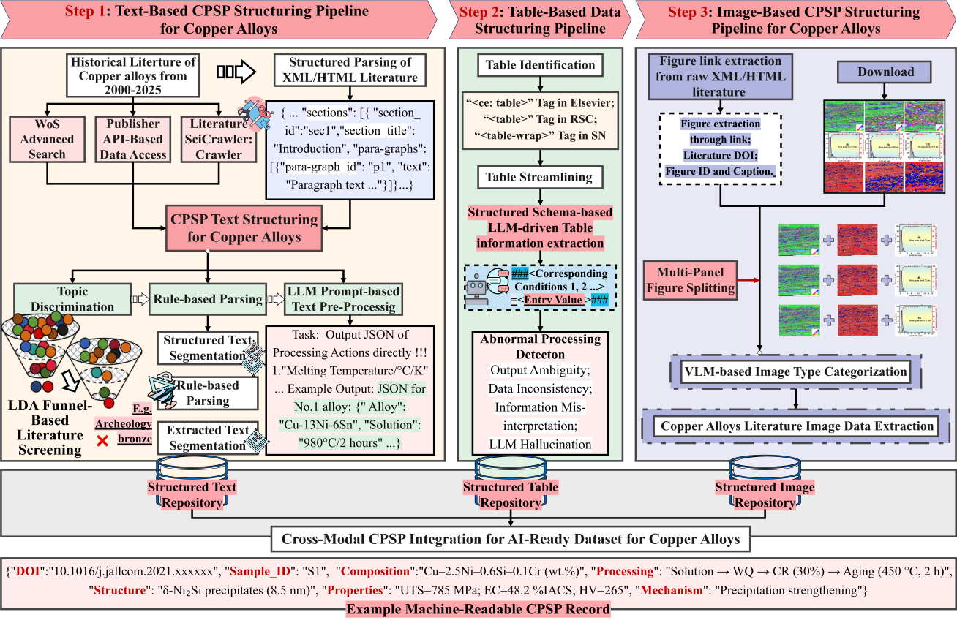
Fig. 4. Document-level multi-modal CPSP reconstruction framework for copper alloys: (A) Text-based CPSP structuring pipeline for transforming unstructured metallur-gical descriptions into machine-readable CPSP records. (B) Table-based structuring pipeline for reconstructing structured CPSP information from heterogeneous literature tables. (C) Image-based structuring pipeline for organizing literature figures, including microstructural images, diffraction patterns, statistical plots, and performance curves. Structured text, table, and image resources are subsequently integrated into a unified CPSP-oriented copper alloy repository. (Revised Figure 4 more clearly illustrate what information is extracted)
The resulting graphical records are subsequently merged with the structured outputs generated by the table-processing pipeline. Rather than being archived as independent visual resources, all reconstructed textual, tabular, and graphical information is harmonized through a unified CPSP schema and stored as machine-readable CPSP records using shared identifiers, including publication DOI, alloy system, composition, processing route, processing conditions, performance metrics, and strengthening mechanisms. This repository-level data organization preserves the traceability of each reconstructed data point while providing a standardized knowledge base for downstream machine learning, property prediction, and alloy design. (Explain how are they stored. )

Moreover, it is well known that LLMs do not work perfectly in extracting the information, even in the metadata, and human verification is very costly. The authors should provide detailed information about the performance of automated and manual processes (see, for example, Scientific Data 12, 1235 and Nature Materials 23, 866).

Response:
We sincerely thank the reviewer for this important comment. We fully agree that large language model outputs cannot be assumed to be reliable without systematic quality control and expert verification, and that exhaustive manual checking of all literature-derived records would be prohibitively expensive. Following the two-stage reporting strategy adopted in the referenced Scientific Data study, we have reorganized the corresponding description in the revised manuscript into two complementary components: automated processing and human-in-the-loop validation.
The document-level reconstruction workflow in the present CTD framework is built upon our previously validated DualTrack-MatExtractor. For this copper-alloy-focused study, the original Ground-Truth benchmark was further expanded with representative copper-alloy textual and tabular records, together with a newly annotated scientific-figure classification dataset. The revised manuscript now clarifies the construction of this extended benchmark, the comparison between automated outputs and expert annotations, and its use in evaluating document-level CPSP reconstruction.
In the automated stage, the document-level reconstruction workflow first transforms heterogeneous XML/HTML full-text articles into intermediate machine-readable repres-entations, including hierarchical JSON documents for textual contents, streamlined schema-preserving representations for heterogeneous tables, and metadata-associated figure objects for graphical resources. This intermediate representation substantially reduces the complexity of directly processing raw scientific literature while preserving the contextual relationships required for subsequent information reconstruction.
These pre-structured inputs are subsequently processed through API-based large language models using unified CPSP-oriented extraction schemas. Multiple state-of-the-art LLMs were benchmarked under identical prompting strategies to evaluate their capability for reconstructing structured CPSP records from textual descriptions and heterogeneous tables, while vision-language models were employed for scientific figure categorization. The automated workflow progressively converts fragmented and unstructured literature into standardized CPSP records rather than directly generating database entries from raw documents. For information that can be deterministically verified, an additional automated quality-control layer is applied before reconstructed records are accepted into the repository. For tabular information, every structured output generated by the LLM is automatically compared with its original XML/HTML source rather than only checking the generated text itself. Specifically, each reconstructed entry is required to maintain a one-to-one correspondence with the original table structure, preserving hierarchical headers, merged cells, row–column dependencies, units, and numerical values. For example, a table entry reporting the average precipitate length is expected to be reconstructed as ###<30 pct Rolling><500 °C><θ′ precipitate><Average Length L (nm)>=<72.8 ± 0.3>###, where every contextual condition can be directly traced back to the corresponding XML/HTML table elements. Missing conditions, broken structural markers, unmatched numerical values, or values that cannot be mapped one-to-one to the original table cells are automatically flagged as invalid outputs, thereby effectively detecting incomplete responses, formatting errors, and LLM hallucinations. For graphical information, automated validation focuses on the consistency between the digitized numerical data and the original scientific figure. After axis detection, scale calibration, and curve digitization, each extracted coordinate is reconstructed. For example, a point on an age-hardening curve is represented as ###<Age-hardening curve of Cu–Ni–Si alloy><Aging time (h)><2><Hardness (HV)>=<265>###. The extracted coordinates are subsequently checked against the detected axis labels, units, figure captions, and calibrated coordinate system to ensure numerical consistency with the source figure. Only records that satisfy these structural and numerical validation criteria are incorporated into the unified CPSP repository. These automated tabular validation procedures before expert assessment are described in detail in our previously validated DualTrack-MatExtractor framework.
Following the automated reconstruction and quality control, a human-in-the-loop validation workflow was conducted to establish the Ground-Truth (GT) benchmark for document-level CPSP reconstruction. Building upon the previously validated DualTrack-MatExtractor benchmark, the GT database was further expanded with representative copper-alloy-specific CPSP records together with manually annotated scientific figures, covering textual, tabular, and graphical information. A panel of 5–8 materials researchers with expertise in copper alloy design, thermo-mechanical processing, microstructural characterization, and mechanical property evaluation participated in the annotation process. Representative publications covering different publishers, table layouts, processing routes, and figure types were selected. Instead of directly annotating raw literature, candidate CPSP records generated by multiple LLMs under identical prompting strategies were first produced and subsequently reviewed against the original publications. Each reconstructed record was independently examined by at least two experts. The review focused on the correctness and completeness of CPSP relationships, including composition, ordered processing routes, structure, properties, strengthening mechanisms, and cross-modal consistency among textual, tabular, and graphical information. Disagreements were resolved through expert discussion and final adjudica-tion by a senior materials scientist to establish the reference GT database. The expert-validated GT records were subsequently used to benchmark different LLMs under identical extraction settings. Before evaluation, alloy designations, metallurgical terminology, units, and formatting were normalized to eliminate non-semantic differences. Model outputs were then quantitatively compared with the GT database using precision, recall, F1-score, BLEU score, and category-level accuracy, providing a reliable evaluation of multi-modal CPSP reconstruction performance. The corresponding Ground-Truth construction, automated and human-in-the-loop validation procedures are now described in the revised Materials and Methods section, while the quantitative benchmark results are presented in the revised Results section (Fig. 5).
Revised Results:
4. Validation of Document-Level Multi-Modal CPSP Reconstruction
As shown in Fig. 5A–F, representative LLMs exhibited distinct performance across composition, processing, structure, properties, strengthening mechanisms, and heterogeneous table reconstruction. GPT-4-1106-preview achieved the best overall performance across most text- and table-based tasks, with token-level F1-scores generally exceeding 0.90, followed by Claude-3-Haiku and GPT-4o-mini. In contrast, Moonshot-v1-32k and Spark-4.0-Ultra showed greater performance degradation in semantically complex tasks, particularly structure and strengthening-mechanism extraction. Across models, precision generally exceeded recall, indicating that errors were dominated by missed entities in loosely structured descriptions and multi-step processing routes, while BLEU showed greater variability because of its sensitivity to wording and sequence-level structural differences. Different CPSP categories also exhibited distinct extraction characteristics. Distinct extraction characteristics were observed across CPSP categories. Composition achieved the highest overall performance owing to its standardized numerical and elemental expressions, whereas processing showed relatively high precision but lower recall because of nested thermo-mechanical conditions and multi-step dependencies. Structure, properties, and particularly strengthening mechanisms exhibited greater inter-model variability, reflecting their implicit relationships, diverse metallurgical terminology, and higher semantic complexity. For heterogeneous tables, GPT-4-1106-preview and Claude-3-Haiku maintained high token-level accuracy and precision, whereas lightweight models showed greater degradation for irregular layouts. Recall remained particularly sensitive to omitted headers and merged-cell structures, highlighting complex tabular dependencies as a major source of extraction error.
Beyond textual and tabular modalities, VLM-based evaluation was conducted for literature image understanding. As shown in Fig. 5G, most models achieved overall accuracies above 0.90, demonstrating robust coarse-grained image categorization. Fine-grained evaluation (Fig. 5H–L), however, revealed clear modality-dependent differences. Microstructural images (SEM, TEM, EBSD, and OM) showed balanced accuracy, precision, recall, and F1-score owing to their distinctive morphological and contrast features, while statistical plots and performance curves also exhibited stable performance because of their regular graphical elements, such as axes, legends, markers, and curves. In contrast, XRD and SAED exhibited greater fluctuations and lower recall, as diffraction patterns often occupy small regions and coexist with microstructural images within composite figures. Schematic diagrams were similarly more challenging because their interpretation requires semantic reasoning across labels, arrows, process routes, and symbolic elements. These results indicate that VLM-based information extraction remains strongly dependent on the visual and semantic complexity of scientific figures, while the GT workflow integrating automated verifica-tion with human-in-the-loop validation provides a high-accuracy and reliable benchmark for evaluating multi-modal CPSP reconstruction across text, tables, and figures.
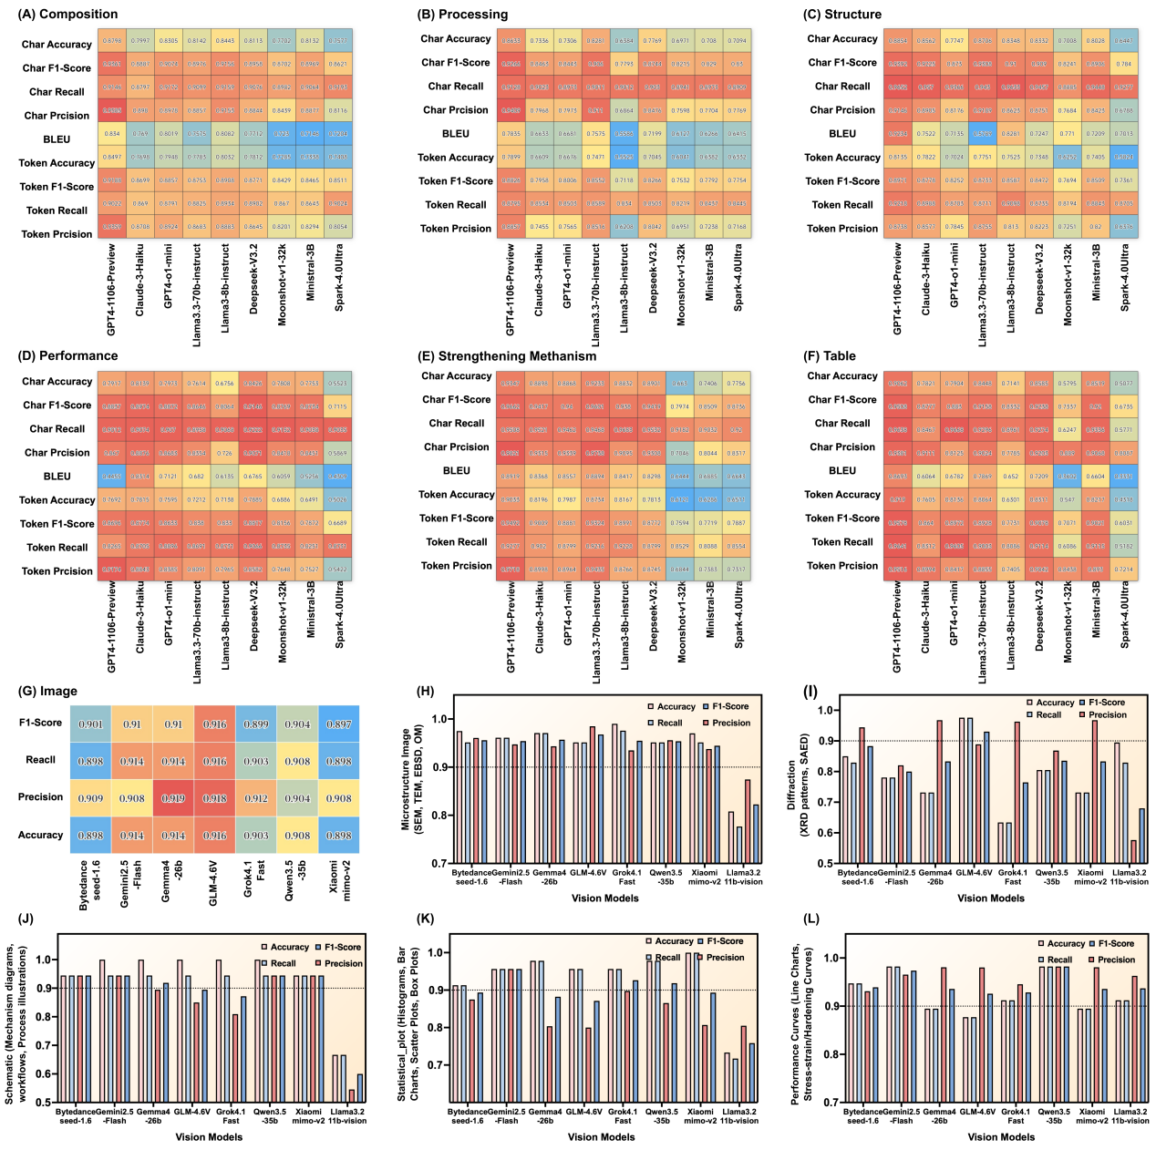
Fig. 5 Benchmark evaluation of LLMs for text- and table-based CPSP extraction and VLMs for scientific figure categorization.(A-F) Heatmap comparison of text- and table-based extraction performance across six CPSP-related categories, including composition, processing, structure, performance, strengthening mechanism, and tabular information. (G) Overall categorization performance of representative VLMs for literature figure understanding. (H-L) Category-level evaluation of VLM-based figure categorization tasks, including microstructural images (SEM, TEM, EBSD, OM), diffraction patterns (XRD plots and SAED patterns), schematic mechanism diagrams, statistical plots (histograms, bar charts, and box plots), and performance curves (line charts and stress-strain/hardening curves).
Revised Materials and Methods:
- Validation of Multi-modal CPSP Reconstruction
A two-stage strategy combining automated validation and human-in-the-loop assessment was adopted to ensure the reliability of document-level CPSP reconstruction and establish the Ground-Truth (GT) benchmark. The established DualTrack-MatExtractor benchmark was further extended with copper-alloy-specific textual and tabular CPSP records and manually annotated scientific figures, resulting in 506 CPSP records with 2,737 annotated entities, 256 heterogeneous XML/HTML tables, and 372 scientific figures across nine categories.
4.1 Automated validation
Candidate CPSP records generated by representative LLMs and VLMs under identical prompting strategies were first subjected to deterministic quality control against the original text, XML/HTML tables, figures, and captions. Structural integrity, contextual consistency, and numerical correspondence were automatically examined. Graphically extracted data were verified against figure captions, axis labels, units, calibrated coordinates, and numerical values, while reconstructed table records were checked against their original XML/HTML structures. Records with incomplete structures, contextual inconsistencies, unmatched values, or invalid source correspondence were flagged for subsequent expert review.
4.2 Human-in-the-loop validation and quantitative evaluation
Following the automated validation, candidate CPSP records were further reviewed by materials researchers and verified by senior domain experts against the original text, XML/HTML tables, figures, and captions. Discrepancies were resolved through expert adjudication, and only consensus annotations were incorporated into the Ground-Truth (GT) benchmark. The resulting benchmark comprised 506 CPSP records with 2,737 annotated entities, 256 heterogeneous XML/HTML tables, and 372 scientific figures across nine categories, covering composition, processing, structure, properties, strengthening mechanisms, and multi-modal reconstruction. Based on the established GT benchmark, multi-modal CPSP extraction performance was quantitatively evaluated using accuracy, precision, recall, F1-score, and BLEU score [37]. Accuracy, precision, recall, and F1-score are defined as follows:
$Accuracy= \frac{TP + TN}{TP + TN + FP + FN}$ (2.4)
$Precision= \frac{TP}{TP + FP}$ (2.5)
$Recall= \frac{TP}{TP + FN}$ (2.6)
$F1−score= \frac{2 × Precision × Recall}{Precision + Recall}$ (2.7)
Here, TP, TN, FP, and FN denote correctly identified target entities, correctly excluded non-target entities, incorrectly generated or misidentified entities, and missed target entities, respectively. Accuracy measures overall agreement with the GT annotations, precision evaluates extraction reliability, recall reflects extraction completeness, and the F1-score balances precision and recall. For textual and tabular extraction, both character- and token-level metrics were calculated, whereas image-based extraction was evaluated using classification-oriented accuracy, precision, recall, and F1-score. BLEU was additionally employed to assess sequence-level similarity between generated outputs and reference annotations, particularly the structural and semantic consistency of CPSP reconstruction. (Revised automated and human-in-the-loop validation of multi-modal CPSP reconstruction section in Methods. Clarify how the Ground-Truth database was established and how expert validation was conducted.)

- The work touches the core correlative (CPSP) knowledge in materials science. However, it is difficult to represent C, P, S and P. The authors should extend the discussion on how it can become possible in this or future work. Secondly, CPSP, especially the processing conditions and evaluation of performance, depend on the choices of experimental setups and standards. These uncertainties can result in notable noise in the data extracted from published journal papers. Conclusions from a data-driven study should be insensitive to these uncertainties. Moreover, commercial and institutional databases provide alternative data sources with usually higher quality of data and data organization. Some comparison may be useful.

Response:
We sincerely thank the reviewer for this insightful comment. We fully agree that CPSP knowledge is considerably more difficult to represent than conventional structured materials data. Following the reviewer’s suggestion, we have expanded the Discussion section to clarify (i) why CPSP knowledge is inherently difficult to represent in the field of material science, (ii) how experimental uncertainties are handled in the proposed framework, and (iii) the relation-ship between the proposed literature-derived repository and existing commercial or institutional databases.
First, the difficulty of CPSP representation does not arise from the four individual components themselves, but from the fact that the corresponding scientific evidence is highly fragmented across different modalities and sections of a publication. Information describing composition, processing conditions, microstructural evolution, properties, and strengthening mechanisms is frequently distributed across the Experimental, Results, and Discussion sections, heterogeneous tables, and scientific figures using diverse termino-logies and reporting styles. More importantly, a single publication often investigates multiple alloy compositions, multiple processing conditions, multiple micro-structural states, and multiple property measurements simultaneously. These heterogeneous observations are linked through complex many-to-many relationships rather than one-to-one correspondences. For example, one alloy composition may undergo several thermo-mechanical processing routes, each producing different microstructural states and multiple property measurements, while the same property may be reported for numerous samples under different experimental conditions. Correctly associating every processing condition with its corresponding sample, microstructure, property, and strengthening mechanism therefore represents one of the major challenges in CPSP reconstruction. Accordingly, the objective of the proposed CTD framework is not merely to extract individual C, P, S, and P entities, but to reconstruct document-level CPSP records by integrating fragmented textual, tabular, and graphical information through shared sample identifiers and contextual relationships. We have clarified this representation strategy and further discussed that future work will extend the current document-level CPSP representation towards hierarchical knowledge graphs and physics-informed reasoning capable of capturing more complex CPSP relationships.
Second, we agree that literature-derived data inevitably contain uncertainties arising from different experimental setups, testing standards, characterization methods, and reporting conventions. Instead of treating these differences as noise to be removed, the proposed framework explicitly preserves the corresponding experimental context together with every extracted data record. In addition to composition, processing route, and property values, the framework reconstructs experimental parameters that may influence the reported results whenever they are available. For example, corrosion records electrochemical testing parameters, while fatigue records retain stress ratio, loading frequency, loading mode, and testing environment. Similarly, for melting and casting processes, experimental conditions including melting equipment, protective atmosphere, casting method, and cooling conditions are reconstructed together with the corresponding processing records. By retaining these experimental conditions rather than discarding them during extraction, potential sources of variability remain explicitly traceable, allowing downstream tasks to perform condition-aware filtering, normalization, or task-specific dataset construction according to different research objectives.
Finally, we agree that curated commercial and institutional databases generally provide highly standardized and quality-controlled datasets. However, the proposed CTD framework is not intended to replace these resources, but to complement them from the perspective of large-scale scientific knowledge acquisition. Unlike conventional data-bases, which mainly store finalized experimental records, the corpus- and topic-level components of the CTD framework continuously organize and utilize the rapidly growing body of scientific literature before knowledge is curated into structured databases. The corpus level enables semantic discovery across more than 100,000 alloy publications, allowing relevant studies to be identified beyond conventional keyword retrieval, while the topic level organizes these publications into interpretable research themes, revealing knowledge evolution, emerging research directions, and semantic relationships that are generally unavailable in existing curated databases. Building upon this global literature organization, the document level further reconstructs fine-grained CPSP records from fragmented textual, tabular, and graphical information. Consequently, the unique value of the CTD framework lies not only in constructing CPSP databases, but also in organizing scientific literature itself into a hierarchical knowledge infra-structure. The corpus level provides a global semantic view of the materials literature landscape, the topic level reveals interpretable knowledge organization and evolution, and the document level reconstructs reusable CPSP records. Together, these three levels establish a scalable pathway from continuously expanding scientific literature to AI-ready knowledge resources, a capability that cannot be achieved by conventional curated databases alone.
Revised Discussions:
Conventional data-driven materials research is predominantly dataset-centered, relying on manual literature collection and static dataset construction prior to machine-learning modeling. Although such workflows have been widely adopted for property prediction and alloy optimization, they generally treat scientific literature primarily as a data source and provide limited support for organizing the broader knowledge landscape or understanding knowledge evolution within a research field [43–45]. This limitation becomes particularly evident for CPSP knowledge, which is inherently difficult to organize because the corresponding scientific evidence is fragmented across textual descriptions, heterogeneous tables, and scientific figures. Moreover, a single publication often reports multiple alloy compositions, processing conditions, microstructural states, and property measurements simultaneously, resulting in complex many-to-many relationships among CPSP components. Consequently, directly transforming literature into structured and reusable CPSP resources remains challenging. (Answer why difficult to represent CPSP). To address this challenge, the proposed Corpus–Topic–Document (CTD) framework progressively organizes scientific literature into machine-readable CPSP resources. It combines large-scale semantic discovery and thematic knowledge organization with document-level reconstruction of fragmented textual, tabular, and graphical evidence, thereby linking research-landscape analysis with data-driven alloy discovery.
The resulting CPSP resources can be reorganized according to alloy system, target property, or metallurgical task, enabling task-oriented dataset generation without repeatedly constructing independent alloy-specific databases. Importantly, experimental context is retained together with each reconstructed record rather than removed during data standardization. Parameters that may influence reported results, such as melting equipment, atmosphere, and casting conditions; corrosion medium, temperature, and electrochemical settings; or fatigue loading mode, stress ratio, frequency, and testing standard—are extracted whenever available and stored with the corresponding CPSP information. These experimental conditions are retained together with each CPSP record, allowing data obtained under different experimental conditions to be identified and filtered separately, which reducing the influence of noise and uncertainties of experiment on subsequent modeling. (Answer how to deal with the noise and uncertainties in CPSP). The proposed framework is not intended to replace commercial or institutional databases, which generally provide highly curated and standardized materials data. Instead, it complements these resources by providing a scalable pathway for continuously converting newly published scientific literature into reusable CPSP knowledge. While curated databases mainly archive validated experimental records, the CTD framework continuously captures newly emerging knowledge, preserves its scientific context, and organizes it into AI-ready knowledge resources before manual curation becomes available. Consequently, CTD serves as an upstream knowledge acquisition framework, whereas commercial databases function as downstream knowledge repositories. Together, they establish a complete knowledge pipeline from scientific discovery to validated materials databases, supporting data-driven materials research throughout the knowledge lifecycle. [46] (Clarify the complementary role of the CTD framework relative to existing commercial databases.).
Despite these advances, several limitations remain. First, the current framework should be interpreted within the scope of repository-level integration. Textual, tabular, and figure-derived information are primarily linked through shared metadata, such as DOI, alloy system, composition, processing route, and performance descriptors, rather than through fully automated entity-level alignment. Consequently, the reconstructed CPSP chains represent coordinated organization of heterogeneous knowledge sources rather than complete cross-modal semantic fusion. While text- and table-based CPSP reconstruction has achieved relatively high reliability, image-derived information is currently used mainly for figure categorization and repository organization. Quantitative extraction of structural descriptors, such as grain size, precipitate characteristics, dislocation density, and texture information, remains limited. Consequently, the current framework is more effective for composition-, processing-, and property-related information than for fine-grained structural knowledge reconstruction. In addition, downstream machine-learning validation was based on randomly partitioned datasets. Although duplicate records were removed and comparable processing routes were selected, latent correlations among literature-derived records may still affect model generalizability. Future efforts may focus on more rigorous validation strategies, quantitative image understanding, and entity-level cross-modal alignment [49–50]. These developments would further enhance the capability of the Corpus–Topic–Document framework to transform scientific literature into actionable knowledge resources, provid-ing a scalable pathway from scientific literature to alloy discovery.

- The authors present experimental data of newly synthesized alloys, but only for “experimental validation”. It is not clear what is the advantage by using the knowledge of using the information from the corpus-topic-document workflow. Are we aiming at, or can we fabricate, new alloys with unreached performance (e.g., Matter 2025, 102377)? Why do we prefer “balanced performance arises from coupled CPSP interactions rather than a single controlling factor” from the engineering aspect? What is the definition of balanced performance? How can the mechanistic and graphic information presented in Fig. 9 be compared to those extracted from the literature, and how can the latter be used for the current experimental exploration? Is it possible to reach scientific discovery of new mechanisms from the current approach? Secondly, the prediction error should be broken down into different sources such as the uncertainties in the literature data as mentioned in previous comments, and the data coverage or model deficiencies.

Response:
We sincerely thank the reviewer for this exceptionally thoughtful and constructive comment. We fully agree that the original manuscript did not sufficiently distinguish experimental validation of a trained model from the more important question of how literature-derived knowledge generated by the CTD framework actually contributes to alloy design. After careful reconsideration, we recognized that several aspects were not sufficiently demonstrated in the original manuscript, including: (i) the additional value of CTD-derived knowledge relative to conventional feature-based modeling; (ii) whether the CTD framework can guide the exploration of alloys toward improved or Pareto-optimal property combinations; (iii) the engineering meaning and quantitative definition of “balanced performance”; (iv) why this balanced performance should be attributed to coupled CPSP relationships rather than a single descriptor; (v) how CTD-derived mechanistic knowledge is translated into the experimental alloy presented in Fig. 9 and whether the present framework can support mechanism discovery; and (vi) how the prediction error should be interpreted in terms of different sources of uncertainty. We have therefore substantially revised Section 5.1 and added a new Fig. 8 specifically to address these issues in an integrated manner.
Firstly, we agree with the reviewer that simply demonstrating good prediction accuracy does not establish the value of the CTD framework. The key advantage should instead be demonstrated by asking whether the knowledge reconstructed and organized by CTD provides additional predictive and design information beyond raw composition/ processing variables and conventional feature engineering. We therefore added a controlled feature-ablation comparison in Fig. 8C–E. The three levels correspond to: raw composition/processing features, conventional physicochemical feature engineering, and CTD-guided feature engineering. Importantly, It are designed to progressively introduce additional knowledge while maintaining comparable modeling conditions. The results show that incorporating physico-chemical features improves the representation of intrinsic alloying mechanism, whereas further introducing CTD-guided descriptors and literature-derived CTD feature relationships provides additional gains in predictive performance.
The contribution of the CTD framework therefore extends beyond simply enlarging the database. By organizing literature information into structured CPSP relationships, It enables the identification of metallurgical patterns that are difficult to capture through conventional literature or text mining alone. These knowledge-derived relationships can then be explicitly incorporated into feature engineering, providing additional physically meaningful information for performance prediction and consequently improving model performance. As illustrated in Fig.8A, this knowledge-discovery process further yields actionable design principles for Cu–Ni–Si alloys, including Ni/Si ratio optimization, thermo-mechanical processing control, and moderate Cr microalloying.
Secondly, we agree that the term balanced performance was insufficiently defined in the original manuscript and could be interpreted qualitatively. In the revised manuscript, we clarify that balanced performance does not imply numerically equal hardness and electrical conductivity, nor simultaneous maximization of both properties. It refers to a non-dominated combination of mechanical and electrical performance in which improvement of one objective is not achieved through an excessive sacrifice of the other. Herein, this concept is evaluated using two complementary criteria with different purposes. The Pareto front serves as the primary multi-objective optimization criterion, identifying non-dominated candidates that achieve the best trade-off between hardness and electrical conductivity. In contrast, the Q3-Euclidean index serves as a secondary ranking metric to prioritize candidates within Pareto-optimal region, thereby facilitating the selection of alloys that simultaneously exhibit superior overall strength–conductivity combinations. Consequently, the final candidate selection combines Pareto-optimality with Q3-Euclidean ranking, ensuring that experimentally investigated alloys satisfy both non-dominated multi-objective optimiza-tion and a high comprehensive performance level.
The present work does not aim to claim a universally record-breaking Cu alloy, but to determine whether CTD-derived CPSP knowledge can efficiently guide the search toward Pareto strength–conductivity front. A total of 950,400 composition–processing combinations were virtually screened, with the highest-ranked candidates concentrated in Cu–Ni–Si compositional subspace for experimental investigation. The experimentally optimized Cu–5Ni–1.5Si–0.25Cr alloy achieved 375 HV, 25.27% IACS, 1133 MPa tensile strength, and approximately 8% elongation, demonstrating a favorable balance of mechanical and electrical performance within the investigated design space.
Thirdly, we agree with the reviewer that the statement “balanced performance arises from coupled CPSP interactions rather than a single controlling factor” should be supported by direct evidence rather than a qualitative interpretation. Likewise, reporting only the overall prediction accuracy without discussing the origin of the remaining prediction error would provide limited insight into the reliability and limitations of the proposed framework. We have therefore revised the manuscript by adding Fig. 8F–G, together with corresponding discussions, to address both aspects.
The original feature-engineering results already demonstrated that the optimized feature subsets differ substantially among the three prediction targets. Hardness is primarily associated with deformation-related variables, Ni/Si ratio, and precipitation-related thermodynamic descriptors, whereas electrical conductivity is more strongly influenced by aging conditions, elemental concentrations, and electron-scattering-related descriptors. The Q3-Euclidean index retains a broader combination of compositional, processing, and thermodynamic variables, indicating different performance objectives rely on distinct CPSP relationships rather than a common feature set.
To further illustrate this point, we added the Pearson correlation heatmap in Fig. 8F, which compares the relationships between representative features with different performance. The purpose of this panel is not to infer causality from Pearson correlation, but to visually demonstrate that the three target properties exhibit markedly different feature–property correlation patterns. This means that hardness and conductivity cannot be optimized within the same feature space, and the comprehensive objective cannot be represented by a single variable. Instead, achieving balanced strength–conductivity performance requires the coordinated regulation of multiple CPSP features, including compositional, precipitation thermodynamics, deformation–aging coupling, solute deple-tion, and processing conditions.
Moreover, the reviewer also suggested that the remaining prediction error should be interpreted in terms of different uncertainty sources. We fully agree with this point. The newly-added Fig. 8G conceptually decomposes the remaining prediction uncertainty into several major contributors, including literature uncertainty, data-coverage limitations, feature-representation limitations, and model approximation error. We emphasize that this analysis is intended as an interpretable attribution framework rather than a rigorous quantitative decomposition into exact percentages. This interpretation is also consistent with the experimental validation results. The hardness prediction errors for the optimized alloys remain around 6%, whereas the electrical-conductivity errors are 4.75% and 13.37%. Fig. 8G further illustrates that the progressive incorporation of physicochemical descriptors and CTD-guided CPSP knowledge continuously reduces the prediction error relative to composition-only features, while remaining residual error should be interpret-ed as the combined consequence of heterogeneous literature data, incomplete coverage of the composition–processing space, missing or insufficiently standardized physical descriptors, and the intrinsic approximation error of the learning model.
Specifically, the subsequent microstructural characterization in Fig. 9 provides experimental support for the expected composition–processing–structure relationships, particularly through the formation of finely dispersed Ni₂Si precipitates together with retained deformation substructures.These observations demonstrate that the experimental results serve as experimental verification of the literature-derived design principles summarized by the CTD framework, establishing an interpretable knowledge chain from CTD-based knowledge mining → metallurgical design principles → alloy design → microstructural evolution → property optimization. We also agree that the current CTD framework is intended for knowledge integration and hypothesis generation rather than autonomous mechanism discovery. It identifies literature-derived CPSP relationships and translates them into testable design principles, while the discovery of new physical mechanisms still requires dedicated experimental characterization and mechanistic validation. We have clarified this methodological boundary in the revised Results and Discussion.
Revised Materials and Methods:
4. Validation of Multi-modal CPSP Reconstruction
A two-stage strategy combining automated validation and human-in-the-loop assessment was adopted to ensure the reliability of document-level CPSP reconstruction and establish the Ground-Truth (GT) benchmark. The established DualTrack-MatExtractor benchmark was further extended with copper-alloy-specific textual and tabular CPSP records and manually annotated scientific figures, resulting in 506 CPSP records with 2,737 annotated entities, 256 heterogeneous XML/HTML tables, and 372 scientific figures across nine categories. Based on the validated CPSP infrastructure, a stagewise prediction-error reduction analysis was further conducted to quantify the incremental contributions of physico-chemical features, CTD-derived metallurgical knowledge, and model optimization to predictive performance.
4.3 Stage-wise Prediction-error Reduction Analysis
A stagewise prediction-error reduction analysis was performed for hardness, electrical conductivity, and Q3-Euclidean to quantify the contributions of physicochemical features, CTD-derived CPSP knowledge, and model optimization. A common subset of 1,136 CPSP records was used across all stages, with the same 8:2 training–testing split (908/228 records), random seed (42), preprocessing procedure, and evaluation metrics to ensure fair comparison. SVR was additionally employed as a simple baseline, while CATBoost (the best-performed model) served as the controlled model for the stagewise analysis. Four cumulative stages were evaluated:
- Stage 0 (Composition): elemental composition only;
- Stage1 (Physics): + Conventional physicochemical, thermodynamic, electronic, configurational features;
- Stage 2 (CTD): + CPSP features derived from CTD-identified metallurgical design rules;
- Stage 3 (Optimization): + Optuna hyperparameter optimization with five-fold cross-validation.
Prediction error at each stage was quantified using normalized root-mean-square error (NRMSE):
$E_{s}=\frac{{RMSE}_{s}}{σ_{y,test}}$ (2.8)
where E_{s} is the normalized prediction error at stage s, RMSE_{s} is the root-mean-square error on the held-out testing set, and σ_{y,test} is the standard deviation of the corresponding testing targets. The incremental prediction-error reduction introduced by each methodo-logical component was calculated as:
$\text{Δ}{\text{E}}_{\text{Physics}}\text{=}{\text{E}}_{\text{0}}\text{−}{\text{E}}_{\text{1}}$ (2.9)
$\text{Δ}{\text{E}}_{\text{CTD}}\text{=}{\text{E}}_{\text{1}}\text{−}{\text{E}}_{\text{2}}$ (2.10)
$\text{Δ}{\text{E}}_{\text{Model}}\text{=}{\text{E}}_{\text{2}}\text{−}{\text{E}}_{\text{3}}$ (2.11)
where E₀–E₃ denote the prediction errors of Stages 0–3, respectively. Accordingly,
${\text{E}}_{\text{0}}\text{=Δ}{\text{E}}_{\text{Physics}}\text{ +Δ}{\text{E}}_{\text{CTD}}\text{ +Δ}{\text{E}}_{\text{Model}}\text{ +}{\text{E}}_{\text{3}}$ (2.12)
Revised Results:

5. Downstream Validation: Rapid Data-Driven Copper Alloy Design Enabled by ML

5.1 Data-Driven Feature Engineering and Multi-objective Prediction of Copper Alloys
To evaluate the applicability of the reconstructed CPSP resources for data-driven copper alloy design, 3,358 CPSP records were selected from 9,284 ML-ready data chains by retaining samples with comparable thermo-mechanical processing histories following the route of “Solution → Quenching → Deformation → Aging → Secondary TMP → Secondary Aging” across representative Cu–Ni–Si- and Cu–Cr-based alloy systems. Based on these data, multi-objective machine-learning (ML)models were developed for hardness, electrical conductivity and Q3-Euclidean prediction, while the CPSP-oriented feature engineering workflow was employed to identify key descriptors governing composition–processing–structure–performance relationships. The dataset was randomly divided into training and testing subsets using an 8:2 ratio, with the testing set reserved for independent evaluation. Within the feature engineering stage, a three-step CPSP-oriented feature screening strategy consisting of correlation filtering, permutation-importance refinement, and combinational optimization was employed to identify key factors governing multi-objective properties in these copper alloy systems [4,40]. As shown in Fig. 6A–6C, Pearson correlation analysis was first performed on the training set to identify features correlated with the target properties from composition-, thermodynamic-, processing-, and physicochemical-related feature spaces, while excluding weakly relevant and redundant variables. Subsequently, recursive feature refinement based on permutation importance and statistical contribution analysis was applied within training set to iteratively eliminate low-contribution features and construct more compact and representative feature subsets (Fig. 6D–6F). Finally, exhaustive combinational searches were performed over the remaining feature subsets to determine the optimal feature combinations by minimizing cross-validation prediction errors within the training set (Fig. 6G–6I). Feature engineering results reveal pronounced target-dependent heterogeneity in CPSP relationships, which is further supported by the SHAP analyses shown in Fig. 7A–C. Hardness is mainly governed by deformation-related parameters, Ni/Si ratio, and precipitation-associated thermodynamic descriptors, highlighting the importance of precipitation evolution and microstructural regulation. In contrast, electrical conductivity is more strongly influenced by aging conditions, elemental concentrations, and electron-scattering-related descriptors, reflecting the effects of solute depletion and phase stability on electron transport. As a coupled metric integrating hardness and conductivity, the Q3-Euclidean index is governed by a broader combination of compositional, processing, and thermodynamic features, indicating that balanced performance arises from coupled CPSP interactions rather than a single controlling factor.
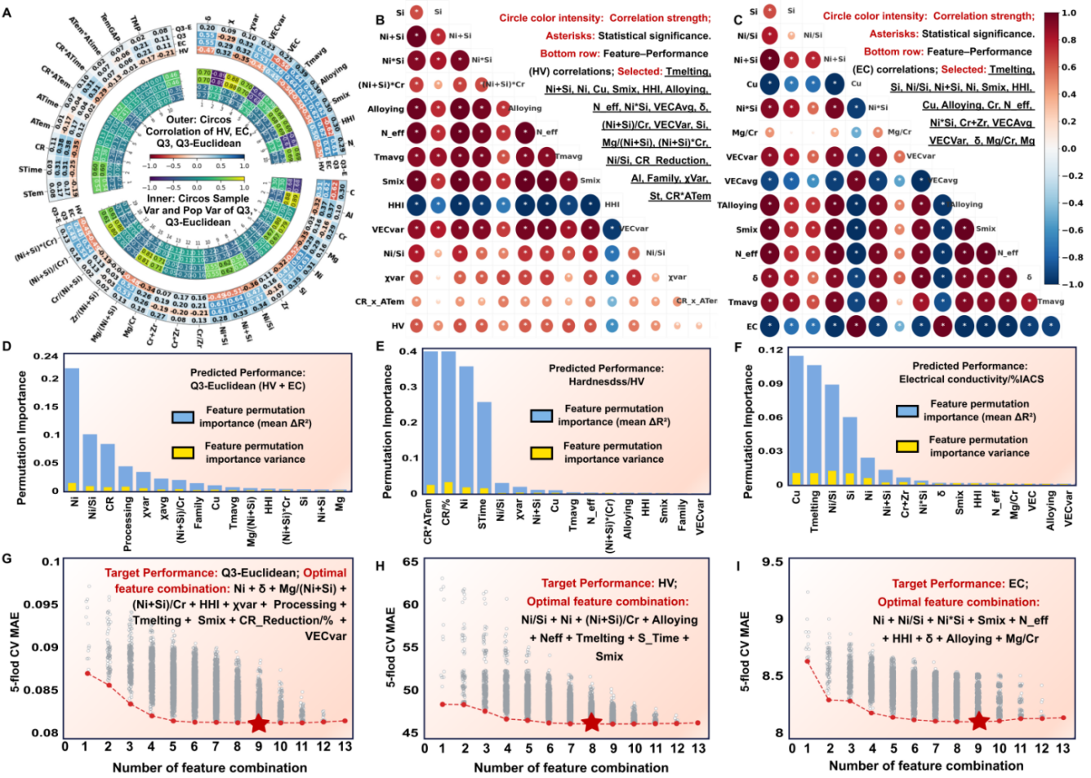
Fig.6. Three-step CPSP-oriented feature selection strategy for downstream machine learning. (A-C) Pearson correlation filtering for Q3-Euclidean, hardness, and electrical conductivity, performed on the training set to remove weakly correlated or redundant features. (D-F) Permutation-importance-based recursive feature refinement for identifying key descriptors associated with each target property. (G-I) Exhaustive search of the remaining feature combinations, showing the variation of mean absolute error (MAE) with feature subset size and the resulting optimal feature subsets.
Based on the optimized CPSP feature subsets, predictive models were developed for representative Cu–Ni–Si–Al–Cr–Mg, Cu–Cr, Cu–Cr–Ni–Si, and Cu–Ni–Si alloy systems. As shown in Fig. 7D–7R, the proposed framework achieved consistently good predictive performance for hardness, electrical conductivity, and the Q3-Euclidean index across different alloy systems. Hardness prediction generally exhibited the highest accuracy, whereas Q3-Euclidean showed greater variability owing to the increased complexity of simultaneously optimizing mechanical strength and electrical conductivity.
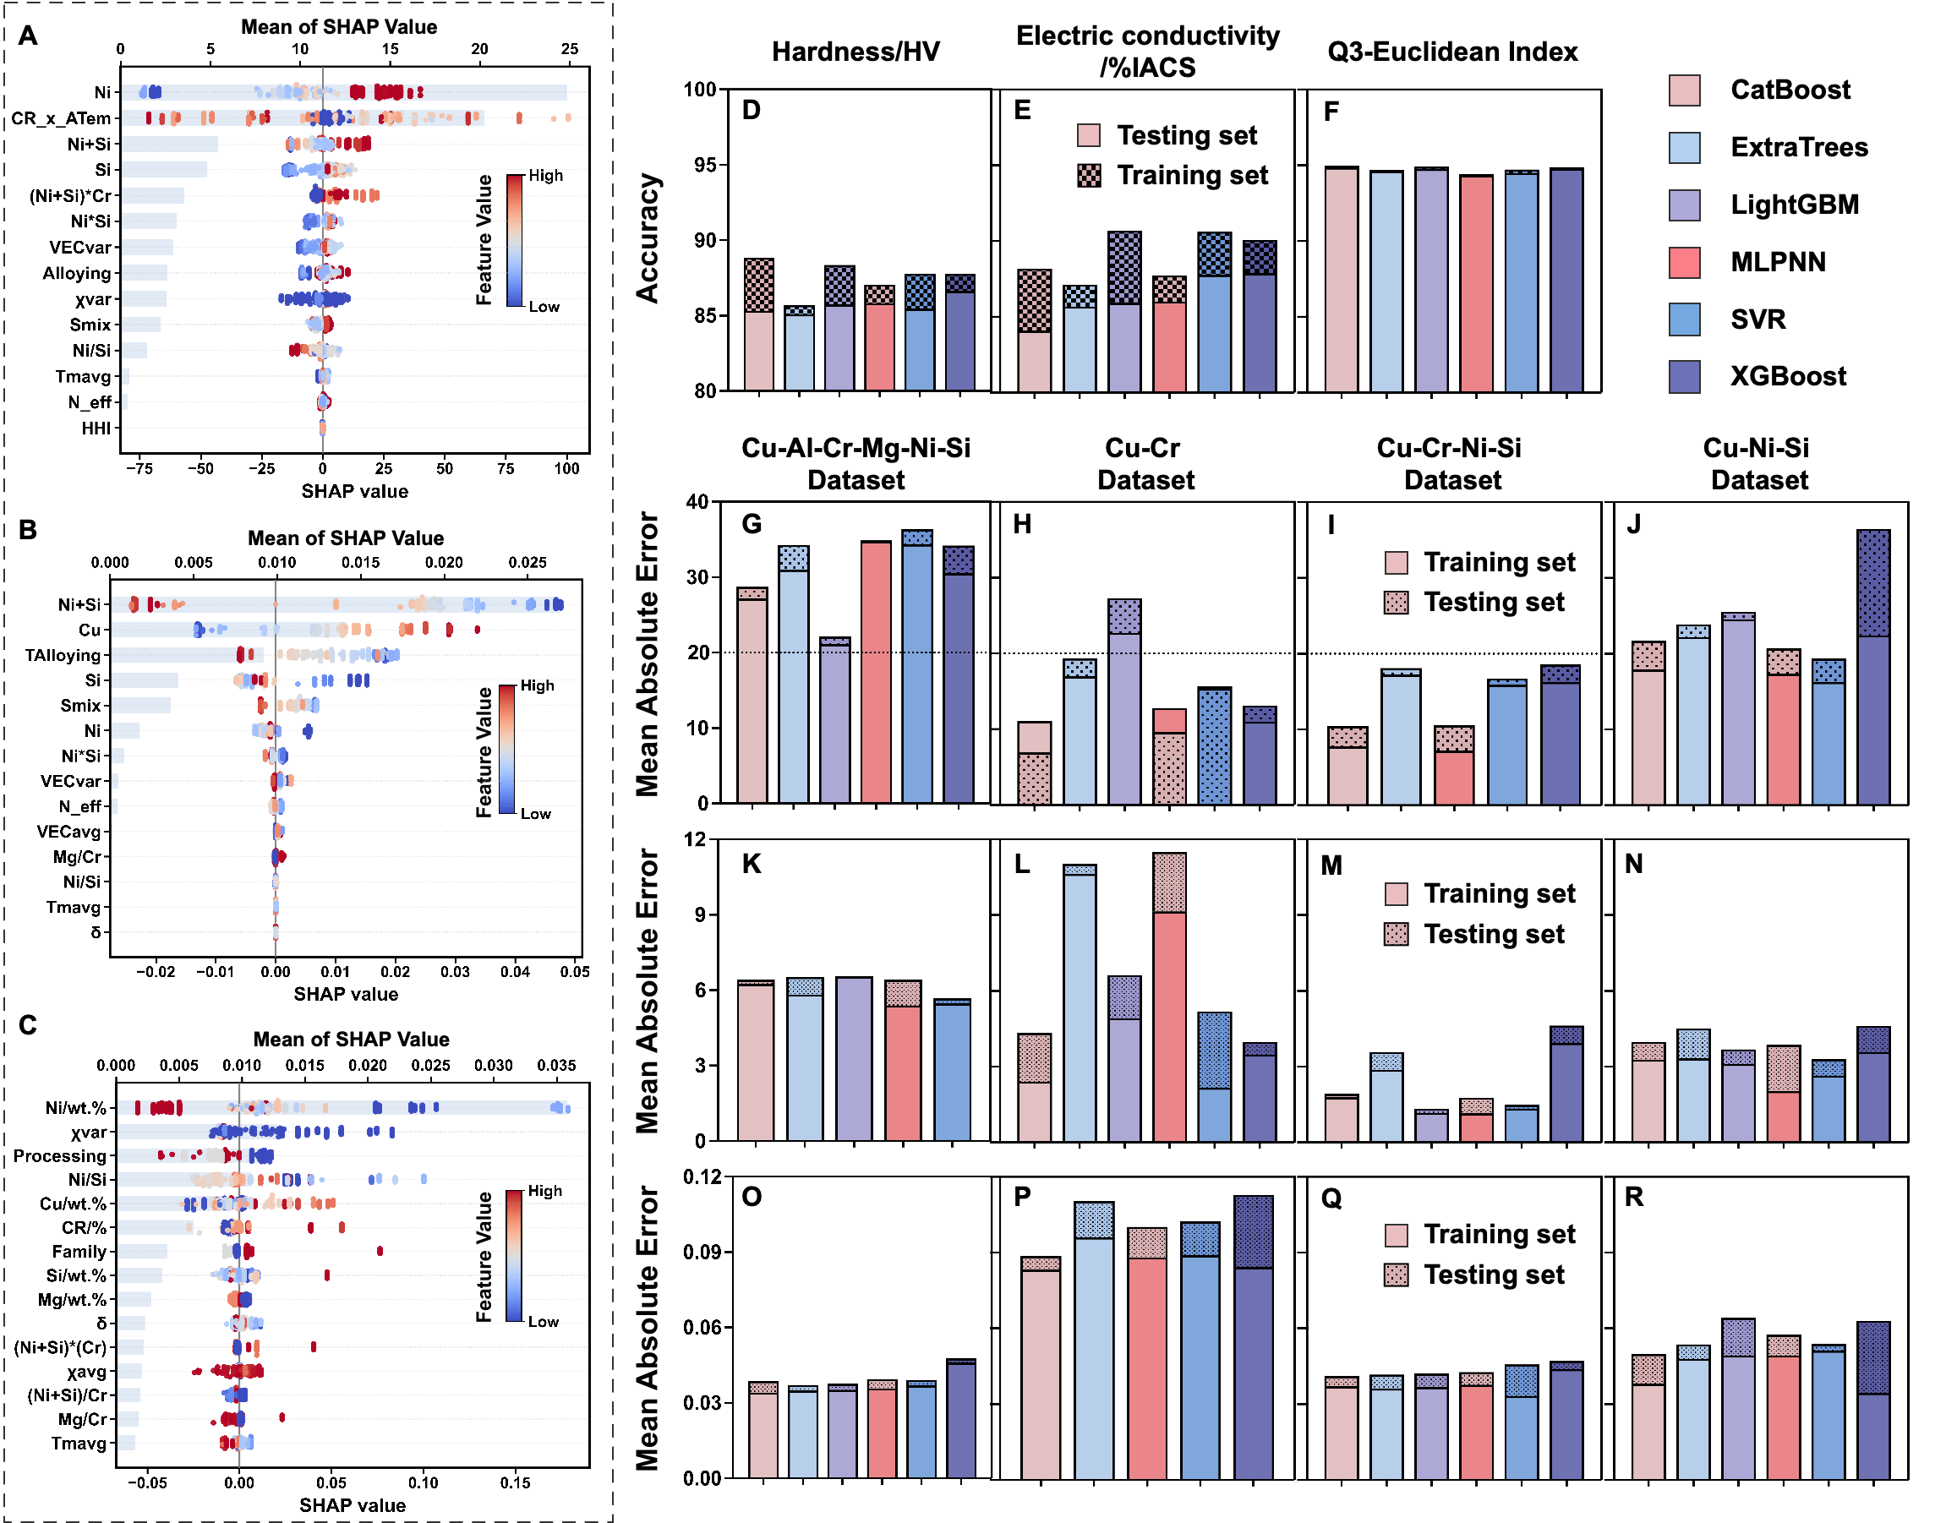
Fig. 7. SHAP feature interpretation and ML prediction performance for the representative copper alloy systems. (A–C) SHAP feature importance analysis for hardness, electrical conductivity, and Q3-Euclidean. (D–F) Prediction accuracy of different machine-learning models across Cu–Ni–Si–Al–Cr–Mg, Cu–Cr, Cu–Cr–Ni–Si, and Cu–Ni–Si datasets using an 80:20 train–test split. (G–R) Mean absolute error (MAE) comparison for hardness, electrical conductivity, and Q3-Euclidean prediction across different alloy systems and models.
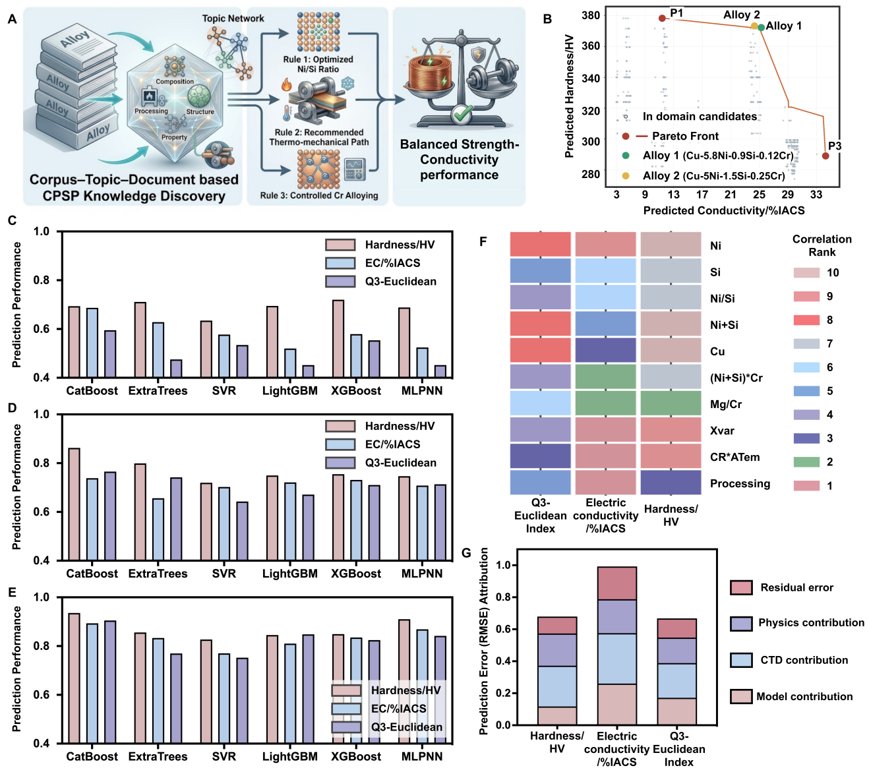
To further demonstrate how the proposed framework translates literature knowledge into practical alloy design, an integrated knowledge-to-design workflow is summarized in Fig. 8. Although the optimized CPSP feature subsets and prediction models provide reliable property prediction, the primary objective of the CTD framework extends beyond predictive modeling to the transformation of literature-derived CPSP knowledge into interpretable and experimentally actionable metallurgical design strategies. Using the Cu–Ni–Si alloy system as a representative example, Fig. 8A illustrates how the reconstructed CPSP knowledge is translated into three literature-derived metallurgical design principles: optimization of the Ni/Si ratio, thermo-mechanical processing control, and moderate Cr microalloying. These principles are systematically extracted from literature-organized CPSP relationships and subsequently guide alloy compositional and processing optimization, providing an interpretable knowledge-mining strategy to data- driven material develpment. For multi-objective alloy design, candidate alloys were first identified from the Pareto-optimal region defined by hardness and electrical conductivity (Fig. 8B). Furthermore, progressive comparisons among raw composition–processing features, conventional physicochemical descriptors, and CTD-guided CPSP features (Fig. 8C–E) demonstrating that literature-derived CPSP knowledge provides additional predic-tive information beyond conventional feature engineering, thereby establishing an interpretable pathway from literature knowledge to knowledge-guided alloy design. The scientific basis of these design principles is further supported by the combined SHAP interpretation (Fig. 7A–C) and Pearson correlation analysis (Fig. 8F), both of which reveal pronounced target-dependent CPSP relationships. Hardness is mainly associated with deformation-related parameters, the Ni/Si ratio, and precipitation-related thermodynamic descriptors, whereas electrical conductivity is primarily governed by aging conditions, elemental concentrations, and electron-scattering-related descriptors. As an integrated metric, the Q3-Euclidean index depends on a broader combination of compositional, processing, and thermodynamic descriptors, demonstrating that balanced strength–conductivity performance requires coordinated regulation of multiple CPSP pathways rather than optimization of a single controlling variable. Fig. 8G shows that prediction-error reduction can be broadly attributed to four components, physico-chemical features, CTD-derived knowledge, model optimization, and residual error with target-dependent proportions. CTD-derived design-rule provide the largest contribution across all three targets, followed by conventional physicochemical features, whereas model optimization and residual error account for comparatively smaller fractions. This indicates that the predictive gains arise primarily from knowledge- and physics-informed feature representation rather than increased model complexity alone.
Fig. 8. CTD-derived CPSP knowledge enables interpretable multi-objective copper alloy design. (A) Translation of CTD-derived CPSP knowledge into metallurgical design principles, including optimization of the Ni/Si ratio, thermo-mechanical processing, and moderate Cr microalloying. (B) Prediction Pareto front for the hardness and electrical conductivity with the experimentally validated Cu–Ni–Si–Cr alloy candidates. (C–E) Comparison of prediction performance using raw composition/processing features, conventional physicochemical feature emgineering, and CTD-guided feature engineering. (F) Pearson correlation heatmap showing the distinctions between representative features with hardness, electrical conductivity, and the Q3-Euclidean index. (G) Schematic of prediction uncertainty attribution, including literature uncertainty, model approximation, CTD knowledge representation, and remaining physical-information limitations.

- The content of the work is very rich, and the figures are very busy. A summary should be given, listing the important findings from the organized data.

Response:
We sincerely thank the reviewer for this valuable suggestion. We fully agree that, although the manuscript presents extensive analyses spanning corpus-level semantic discovery, topic-level knowledge organization, document-level CPSP reconstruction, and downstream alloy design, the principal scientific findings revealed by the organized data were not previously synthesized into a concise overview. Following the reviewer’s suggestion, we have added a new Supplementary Summary section (Supplementary Note S1, Scientific Findings Revealed by the Corpus–Topic–Document Framework, Pages 3-10) together with a corresponding summary figure, specifically designed to summarize the major scientific findings obtained from the organized data rather than reiterating the CTD workflow.
The newly added summary organizes the results into four levels of scientific findings about Corpus, Topic, Document, and Application，and summarizes XXX representative scientific findings revealed by the organized data. Specifically, the summary highlights: (i) the large-scale evolution of the copper-alloy research landscape, including publication patterns, geographical distribution, institutional and funding characteristics, and long-term research trends; (ii) the major semantic organization patterns and thematic evolution revealed by BERTopic and LDA analyses, demons-trating how heterogeneous literature can be organized into scientifically interpretable research domains; (iii) characteristics of the reconstructed CPSP infrastructure, including its knowledge coverage, representative alloy systems, CPSP information organization, and transformation into task-oriented ML-ready datasets; and (iv) the key scientific insights obtained from downstream machine learning and alloy design, including CPSP-governed feature relationships, multi-objective property prediction, Bayesian optimiza-tion, and experimental validation.
Unlike the workflow figures presented throughout the manuscript, the newly added summary focuses on what has been learned from the organized data, allowing readers to rapidly identify the principal scientific insights enabled by the proposed CTD framework. We believe this addition substantially improves the readability of the manuscript and provides a concise overview of the major discoveries derived from the organized copper-alloy knowledge infrastructure. Corresponding summary has been added in (Supplementary Note S1, Pages 3-10) and is referenced at the end of the revised results section overview of the CTD framework for copper alloy informatics (Page XXX, Lines XXX–XXX).
Revised Results:
Results
- Overview of the CTD Framework for Copper Alloy Informatics
......
Subsequently, at the document level, fine-grained CPSP reconstruction is performed for individual publications through three complementary pipelines for text, tables, and figures. The textual pipeline uses LLMs to extract implicit metallurgical knowledge from natural-language descriptions, while the tabular pipeline combines rule-based parsing with schema mapping to extract numerical data from heterogeneous tables. The graphical pipeline classifies and interprets microstructural images (SEM, TEM, OM, and EBSD), diffraction patterns (XRD and SAED), performance curves, and statistical plots to capture structural evolution and property responses. These complementary modalities are integrated into unified CPSP data chains and further transformed into ML-ready copper-alloy resources for property prediction, multi-objective optimization, and experimental validation (Fig. 1a). As illustrated in Fig. 1b, the workflow represents a unified transformation from raw literature resources to ML-ready CPSP knowledge. Horizontally, multi-modal literature progresses through corpus-level relevance selection, topic-level knowledge organization, and document-level CPSP reconstruction to predictive modeling; vertically, different categories of materials information, including composition, processing, structure, and properties, are systematically encoded into a unified attribute space, ensuring consistency across heterogeneous modalities. Within this two-dimensional representation, multi-modal inputs are first decomposed into semantic units, then organized through corpus- and topic-level semantic structures, and ultimately mapped into CPSP-aligned data chains. The major scientific findings revealed by the CTD-organized data across the corpus, topic, document, and application levels are summarized in Supplementary Note S1.

Revised Supplementary Material:

Supplementary Note S1. Scientific Findings Revealed by the Corpus–Topic–Document Framework

The proposed Corpus–Topic–Document (CTD) framework revealed a series of scientific findings spanning corpus-level literature patterns, topic-level semantic structures, document- level CPSP relationships, and downstream data-driven alloy design, as summarized below.

S1.1 Corpus-level findings-Knowledge discoveries from the global copper-alloy literature landscape

Finding 1. Copper-alloy research expanded markedly during 2020–2025 while remaining concentrated within a relatively stable publication ecosystem.
- Supporting evidence and interpretation:
Supplementary Figure S1 and Supplementary Table S1 track the annual rankings of the major publishers and journals contributing to copper-alloy research from 2020 to 2025. Elsevier and its affiliated imprints consistently maintained clear leadership throughout the study period, while Journal of Alloys and Compounds, Materials Science and Engineering A, and Journal of Materials Research and Technology remained the principal publication venues. At the same time, Materials & Design, Materials Characterization, and Journal of Materials Engineering and Performance showed more pronounced growth after 2023. These results indicate that copper-alloy research has expanded continuously within a publication ecosystem that remains concentrated around several dominant publishers and journals.

Finding 2. The global copper-alloy research ecosystem is becoming increasingly Asia-centered, with publication output, institutional leadership, and funding support showing a consistent geographical concentration.

- Supporting evidence and interpretation:
Supplementary Figure S1.C-F show the temporal evolution of publishing countries, research institutions, and funding agencies. China consistently dominates publication output, while India shows rapid growth and Japan and Russia remain comparatively stable. At the institutional level, the Chinese Academy of Sciences, Central South University, and the University of Science and Technology Beijing consistently rank among the leading contributors, supported by other major Chinese institutions such as Northeastern University and Harbin Institute of Technology. A similar pattern is observed in research funding, where the National Natural Science Foundation of China remains the dominant funding source, followed by the National Key R&D Program of China and several provincial foundations. The consistency among country-, institution-, and funding-level distributions indicates an increasingly Asia-centered copper-alloy research ecosystem.

Finding 3. Copper-alloy knowledge occupies a heterogeneous, long-tailed, and cross-domain semantic landscape rather than a single isolated literature region.

- Supporting evidence and interpretation:
Figure 2A–B shows that BERTopic–UMAP identified 457 non-noise semantic clusters from 122,982 alloy-related publications, with the largest individual cluster accounting for only 2.57% of the corpus. The remaining clusters exhibit a pronounced long-tail distribution, while dense local topic regions remain globally interconnected in the semantic space. Copper-alloy-related publications are not confined to a single semantic cluster but are distributed across multiple neighboring research domains, including mechanics, corrosion, high-entropy alloys, irradiation, and shape-memory alloys. These results demonstrate that copper-alloy knowledge is semantically heteroge-neous and extensively connected with adjacent materials-research domains.

Finding 4: Copper-alloy research is undergoing a gradual shift from composition- and performance-centered development toward microstructure-informed, processing-mediated, and engineering-oriented design.

- Supporting evidence and interpretation:
Supplementary FigS1.E shows that microstructure, mechanical properties, evolution, strength, precipitation, temperature, deformation, corrosion, and phase remain among the dominant research keywords. The temporal analysis further shows that microstructure, mechanical properties, and evolution remain persistent high-frequency themes, while corrosion and processing-induced precipitation behavior have gained increasing attention in recent years. Supplementary Materials explicitly interpret this transition as a gradual shift from composition-centered alloy development toward more integrated strategies emphasizing microstructure-informed and engineering application-oriented design, together with increasing integration of processing–structure–property relation-ships with reliability, durability, and functional requirements.

S1.2 Topic-level findings Knowledge organization revealed by semantic topic modeling

Finding 5. The heterogeneous copper-alloy literature can be organized into seven scientifically interpretable thematic domains with a clear hierarchical and long-tail structure.

- Supporting evidence and interpretation:
Figure 2C–D, Figure 3A–D, and Table 1 collectively characterize the LDA-derived thematic organization of the copper-alloy corpus. The coherence score reaches its maximum at seven topics, while the reconstructed topics correspond to recognizable research directions including structure–property relationships, corrosion, interfacial reactions, electrodeposition, solidification/diffusion, amorphous systems, and functional materials. At the same time, Figure 3B shows an uneven topic-weight distribution, with several dominant themes accompanied by smaller but meaningful topics, forming a clear long-tail structure. These results indicate that copper-alloy research is neither randomly distributed nor uniformly partitioned, but instead organized into a limited number of scientifically interpretable domains with distinct levels of prominence.

Finding 6. Structure–property relationships remain central to copper-alloy research, while the field is increasingly shifting toward service-oriented performance and application-relevant behavior.

- Supporting evidence and interpretation:
Figure 2D and Figure 3D show that structure-related studies consistently occupy a major proportion of the literature, confirming the persistent importance of linking microstructure with properties in copper-alloy research. Meanwhile, the increasing prominence and temporal variation of topics such as corrosion, surface reactions, wear, interfacial phenomena, and other environment-dependent behaviors indicate a growing emphasis on alloy performance under practical service conditions. Together, these trends suggest that copper-alloy research is evolving from primarily structure–property optimization toward a more application- oriented paradigm that integrates microstructural regulation with service performance, reliability, and environmental response.

Finding 7. The major thematic domains are semantically distinguishable but not completely isolated, revealing a structured and partially interconnected knowledge landscape.

- Supporting evidence and interpretation:
The inter-topic correlation matrix in Figure 3C shows moderate correlations among the reconstructed topics, indicating clear thematic separation. Figure 2C shows that these topics remain partially connected within the semantic space rather than forming completely isolated clusters. This combination of distinguishable and limited semantic overlap suggests that copper-alloy research organized into identifiable thematic modules while retaining shared scientific concepts across neighboring research directions.

S1.3 Document-level Scientific findings from the reconstructed CPSP infrastructure

Finding 8. The reconstructed CPSP infrastructure transforms fragmented literature into reusable knowledge that can directly support alloy design.

- Supporting evidence and interpretation:
The document-level reconstruction integrates information extracted from text, tables, and scientific figures into unified CPSP records preserving composition, processing history, structural observations, strengthening mechanisms, properties, publication meta-data, and experimental context within machine-readable JSON documents. Reconstruct-ed CPSP infrastructure functions as a reusable knowledge resource from which task-specific datasets can be dynamically generated according to alloy system, processing route, target property, or metallurgical objective. This organization enables the same literature-derived knowledge to support knowledge mining, feature engineering, property prediction, and alloy design without repeatedly reconstructing alloy-specific databases.

Finding 9. CPSP-derived knowledge enables interpretable machine learning and experimentally validated alloy design.

- Supporting evidence and interpretation:
Task-specific datasets generated from CPSP infrastructure supported CPSP-oriented feature engineering, multi-objective property prediction, Bayesian optimization, and subsequent experimental validation. The optimized feature subsets demonstrate that hardness, electrical conductivity, and Q3-Euclidean are governed by different CPSP descriptor combinations rather than a universal feature family. Guided by these knowledge-derived relationships, virtual screening of the composition–processing design space identified optimized Cu–Ni–Si–Cr alloy candidates, which were subsequently validated experimentally. Microstructural characterization further confirmed that the balanced mechanical and electrical performance originated from coordinated regulation of alloy composition, thermo-mechanical processing, retained deformation substructures, and nanoscale δ-Ni₂Si precipitation, thereby establishing a complete knowledge-driven pathway from literature organization to alloy discovery.

S1.4 Knowledge-utilization Scientific discoveries enabled by CPSP-guided machine learning
Finding 10. Balanced strength and electrical conductivity require coordinated regulation of precipitation, solute partitioning, and deformation through composition–processing coupling.

- Supporting evidence and interpretation:
Feature engineering reveals that hardness is primarily governed by Ni content, Ni/Si ratio, precipitation-related thermodynamic descriptors, deformation–aging coupling, aging intensity, and supersaturation, indicating that precipitation evolution and deformation strengthening dominate mechanical performance. In contrast, electrical conductivity is mainly controlled by Ni, Si, Ni/Si ratio, Cr-related descriptors, configura-tional/electronic features, and aging-related processing interactions, reflecting the importance of solute depletion, matrix purification, and electron scattering. The Q3-Euclidean index depends on a broader combination of compositional, thermodynamic, and processing descriptors, demonstrating that balanced performance cannot be achieved by optimizing a single variable. Therefore, high-performance Cu–Ni–Si alloys should be designed by jointly regulating precipitation evolution, solute partitioning, and deforma-tion through coordinated composition and thermo-mechanical processing.

Finding 11. Optimizing precipitation evolution while preserving a conductive Cu matrix is the fundamental design principle for high-performance Cu–Ni–Si alloys.

- Supporting evidence and interpretation:
The CTD framework identifies Ni content, Ni/Si ratio, Cr micro-alloying, deformation, and aging as recurrent key variables across literature. These variables collectively regulate δ-Ni₂Si precipitation, retained deformation substructures, and matrix purification. Experimental validation confirms that the optimized alloy achieves balanced strength and conductivity through uniform nano-sized δ-Ni₂Si precipitates, moderate retained dislocations, and a purified Cu matrix. Therefore, core metallurgical objective is controlled precipitation evolution with minimum electron scattering, rather than maximizing precipitation alone. It also verify that simultaneous optimization of precipitation behavior, matrix chemistry, and thermo-mechanical processing is essential for achieving balanced mechanical and electrical properties.

- I would suggest the authors share their data in a readable way, which can help the reviewers and readers to understand the work better.

Response:
We sincerely thank the reviewer for this valuable suggestion. We fully agree that making the underlying data and intermediate resources available in a clear and reusable format is important for improving the transparency, reproducibility, and accessibility of this work. Following the reviewer’s suggestion, we have further organized the data, source files, and intermediate results associated with the proposed CTD framework and made them publicly available through our GitHub repositories. Specifically, the complete literature parsing and multi-modal CPSP extraction workflow, including XML/HTML processing, text extraction, heterogeneous table reconstruction, figure processing, and structured CPSP generation, has been released through the DualTrack-MatExtractor repository. This repository contains the complete extraction pipeline, source code, representative input files, intermediate processing results, configuration files, and example outputs, allowing readers to reproduce the entire literature-to-CPSP reconstruction workflow.
The structured copper-alloy knowledge infrastructure generated in this work has been separately released through Copper-CPSP-infrastructure repository. In addition to the Supplementary Materials, this repository provides the structured copper-alloy database, representative CPSP records, topic-modeling results, feature descriptors, and supporting datasets used for downstream data-driven alloy design. The current database contains 7,963 structured CPSP records covering 92 representative copper alloy systems, together with corresponding composition, processing, structure, property, and strength-ening-mechanism information, enabling readers to directly inspect the reconstructed CPSP knowledge and its organization.
We have also revised the manuscript to explicitly direct readers to these public repositories in the Data Availability section. Together with the Supplementary Materials, these openly available resources provide comprehensive access to the extraction work-flow, structured databases, and supporting data used throughout this study, thereby substantially improving the readability, reproducibility, and reusability of the proposed CTD framework.
GitHub repositories:
- DualTrack-MatExtractor (multi-modal literature extraction framework): https://github.com/zhaozixuan6678/DualTrack-MatExtractor.
- Copper-CPSP-infrastructure (structured copper-alloy CPSP repository):
https://github.com/zhaozixuan6678/Copper-CPSP-infrastructure.

Reviewer #2's comments:
This work aligns closely with the scope of Materials Genome Engineering Advances, as it directly tackles the foundational challenge of transforming fragmented scientific literature into FAIR (Findable, Accessible, Interoperable, Reusable) know-ledge infrastructure for materials genome engineering. The proposed Corpus-Topic-Document (CTD) framework integrates large-scale literature mining, multi-modal information extraction, and machine-learning-guided alloy design, culminating in experimental validation of a high-performance Cu-Ni-Si-Cr alloy. The end-to-end pipeline exemplifies the “literature-to-discovery” paradigm championed by the journal. However, several critical issues regarding semantic filtering methodology, feature representation completeness, and cross-source data harmonization must be addressed to meet the journal’s standards for rigor in materials informatics.

- The manuscript highlights BERTopic-UMAP-based semantic filtering as a key improvement over traditional keyword search, but the distinction between these approaches is under-explained. For readers invested in materials genome infrastruc-ture, a concrete comparison is essential: Traditional keyword filtering relies on exact term matching. The proposed semantic filtering embeds full text (title, abstract, keywords) into a high-dimensional vector space, where proximity reflects semantic similarity rather than lexical overlap. The manuscript does not quantify the improve-ment of semantic filtering over keyword-based baselines. Please add a comparative analysis as suggested (can be revised to similar ones): (1) Report the number of false positives/negatives in keyword-based retrieval vs. BERTopic filtering for a held-out test set of 500 manually labeled publications; (2) Discuss the trade-off between semantic filtering’s higher recall (capturing implicit Cu alloy studies) and potential noise from semantically adjacent but irrelevant topics. This will strengthen the case for semantic filtering as a core enabler of materials genome-scale literature mining.

Response:
We sincerely thank the reviewer for this important suggestion. We agree that the original manuscript did not sufficiently distinguish BERTopic–UMAP semantic filtering from conventional keyword-based retrieval, particularly in terms of their retrieval mechanisms, quantitative performance, and the trade-off between improved coverage and semantic noise. In response to this comment, we performed an additional controlled ground-truth validation experiment specifically designed to quantify these differences.
First, we constructed a record-level Ground-Truth (GT) benchmark comprising 500 publications sampled from the BERTopic-defined copper-alloy candidate cohort. To ensure traceability, each publication was assigned a persistent cohort identifier and linked to its original CTD document identifier, while its title, abstract, Author Keywords, Keywords Plus, DOI, source information, semantic evidence, retrieval outputs, and resolved GT annotation were retained in separate data layers. Relevance was determined using a predefined material-scope criterion: copper or a copper alloy had to constitute the principal material system, experimental object, or property-bearing material of the study. Of the 500 publications, 436 records with explicit and internally consistent Cu-alloy evidence formed a preconfirmed positive stratum, whereas 64 less explicit or context-dependent boundary records underwent individual record-level assessment based on their principal material, role of copper, research objective, and processing–structure–property context. Each resolved record was further documented with a material-scope category, confidence level, evidence-based rationale, and review status. The resulting GT bench-mark contained 488 relevant and 12 non-relevant publications.
Second, we established a controlled comparison to separate the effects of metadata coverage from semantic representation. The keyword-only baseline applied predefined inclusion and exclusion rules to Author Keywords and Keywords Plus. The full-metadata lexical baseline applied exactly the same lexical rules to the concatenated title, abstract, Author Keywords, and Keywords Plus. Finally, BERTopic–UMAP used the same four metadata fields but represented each publication in a dense document-level semantic space, where copper-alloy-relevant publications were identified according to contextual similarity rather than exact lexical overlap. This design therefore allowed us to determine whether the observed improvement originated simply from access to more metadata or from semantic representation itself.
The comparison quantitatively confirms the limitation of exact lexical matching. Keyword-only retrieval identified 302 of the 488 GT-relevant publications and produced 186 false negatives, corresponding to a precision of 98.4%, recall of 61.9%, and F1-score of 76.0%. Extending the same lexical rules to the full metadata substantially improved retrieval, but 48 relevant publications were still missed, yielding a recall of 90.2% and F1-score of 93.6%. In comparison, BERTopic–UMAP retained all 488 GT-relevant publications within the evaluated cohort, reducing the false-negative count to zero and increasing the F1-score to 98.8%, while maintaining a precision of 97.6%. We further performed record-level error analysis of FP and FN cases, as suggested by the reviewer. FN from the lexical approaches were primarily publications described through specific alloy designations, processing conditions, phase terminology, or structure–property relationships without explicit generic expressions such as “copper alloy” or “Cu alloy.” These FN cases explain why semantic representation is particularly useful for materials literature, where the identity of a material system is often encoded implicitly through metallurgical context rather than standardized terminology. At the same time, we agree that the higher semantic coverage introduces a recall–noise trade-off. BERTopic–UMAP retained 12 non-relevant publications, resulting in 12 false positives and a precision of 97.6%. These false positives were mainly semantically adjacent studies involving non-Cu-base alloys, dissimilar interfaces, coatings, or electrolysis-related applications. Thus, semantic filtering does not eliminate retrieval noise completely in some cases.
Accordingly, we revised both the main manuscript and the Supplementary Materials. To maintain the readability of the main text, we added only the principal comparison and conclusion, emphasizing that BERTopic–UMAP substantially reduces the false-negative problem associated with lexical retrieval while introducing only limited semantic contamination. The complete validation experiment, including GT database construction, the 436/64 stratified annotation procedure, the controlled three-method comparison, evaluation definitions, record-level TP/TN/FP/FN analysis, and the discussion of lexical omission and semantic noise—has been added as Supplementary Note S5, “Ground-truth Validation of BERTopic–UMAP Semantic Filtering.” The composition of the 500-publication GT benchmark is summarized in Supplementary Table S5, and the complete quantitative comparison of keyword-only, full-metadata lexical, and BERTopic–UMAP filtering is provided in Supplementary Table S6. We believe that this additional validation directly addresses the reviewer’s concern and provides quantitative evidence that the principal advantage of BERTopic–UMAP is not merely broader metadata coverage, but its ability to recover metallurgically relevant yet lexically under-specified publications, which is particularly important for materials genome-scale literature mining.

Revised Supplementary Material:

Note S5: Ground-truth Validation of BERTopic–UMAP Semantic Filtering

- Ground-truth database: A record-level ground-truth database was constructed to provide a common reference for evaluating the three literature-filtering strategies. The database comprised 500 publications sampled from the BERTopic-defined copper-alloy candidate cohort. Each record was assigned a persistent cohort identifier and linked to its original CTD document identifier to preserve provenance. The bibliographic layer retained the title, abstract, Author Keywords, Keywords Plus, DOI, Web of Science accession number, publication year, source title and document type. The semantic-evidence layer contained the BERTopic topic assignment, similarity to positive and negative semantic anchors, semantic margin and selection basis. A separate evaluation layer stored the outputs of keyword-only retrieval, full-metadata lexical retrieval and BERTopic–UMAP filtering. The reference layer recorded the resolved binary relevance label, material-scope category, annotation confidence, evidence-based rationale, review status and provenance of the annotation. This relational organization separated source metadata, model-derived evidence, reference labels and evaluation outcomes, thereby enabling every TP, TN, FP and FN to be reconstructed and traced to the original publication. The GT database therefore functioned not only as an evaluation set but also as an auditable data resource for examining the lexical omissions and semantic noise introduced by different corpus-construction strategies.

- Comparison design: Three literature-screening strategies were evaluated on the same 500- record dataset using an identical definition of copper-alloy relevance. The keyword-only baseline applied a predefined set of inclusion and exclusion expressions to the Author Keywords and Keywords Plus fields. The inclusion dictionary covered generic terms, such as “copper alloy” and “Cu alloy,” together with commonly used Cu-based alloy designations. Exclusion rules were used to suppress records in which copper-related terms occurred only in clearly non-target contexts. The full-metadata lexical baseline applied the same dictionary and matching rules to the concatenated title, abstract, Author Keywords and Keywords Plus fields. Thus, the difference between the two lexical baselines arose exclusively from the metadata fields available for exact term matching. For semantic filtering, the same four metadata fields were encoded as dense document-level semantic representations. BERTopic– UMAP organized these representations according to their contextual similarity and identified the semantic neighborhood associated with copper-alloy research. Unlike the lexical methods, this procedure did not require a publication to contain a specific copper-alloy expression; it could therefore retain records described through alloy designations, processing routes, phase terminology or characteristic structure–property relationships. The three methods were applied independently to the same records, and their outputs were preserved as binary retrieval decisions. Neither the keyword dictionary nor the semantic-selection criteria were modified after inspection of the final GT labels.

- Annotation procedure: Relevance annotation was performed using a predefined material- scope protocol applied consistently across the 500 records. The central question was whether copper or a copper alloy constituted the principal material system, experimental object or property-bearing phase investigated in the publication. Annotation decisions were based on the combined evidence from the title, abstract, Author Keywords and Keywords Plus, rather than on the presence of an isolated occurrence of “Cu” or “copper.” A positive label was assigned when the study primarily examined the composition, processing, microstructure, properties or performance of copper, a copper-based alloy or a Cu-based functional material. A negative label was assigned when copper appeared only as a minor alloying element, substrate, coating support, joining counterpart, interfacial component, catalyst constituent, corrosion-medium component or incidental analytical reference, while another material system remained the principal research object. The annotation was implemented in two stages. First, 436 records showing explicit and internally consistent copper-alloy evidence were assigned to a preconfirmed positive stratum. This evidence typically included a Cu-based alloy designation in the title or abstract together with descriptions of its processing, microstructure or properties. Second, 64 records with less explicit or context-dependent material identities were subjected to record-level assessment. For each of these records, the principal material, role of copper, research objective and reported material processing –structure–property relations were examined jointly. Each annotation was documented using a binary relevance label, a standardized material-scope category, a three-level confidence score and a concise textual rationale citing the decisive bibliographic evidence. Importantly, the GT labels were established independently of the final TP/TN/FP/FN assignment; the predictions of the three filtering methods were compared with the resolved labels only after completion of the annotation dataset. The resulting GT database contained 488 relevant and 12 non-relevant publications, including both explicit copper-alloy studies and implicit studies identifiable only through their broader metallurgical context.

- Evaluation: The output of each filtering method was evaluated against the same resolved binary GT label, with copper-alloy relevance treated as the positive class. A true positive (TP) denotes a GT-relevant publication correctly retained by the filtering method. A false negative (FN) denotes a relevant publication rejected by the method and therefore measures retrieval omission. A false positive (FP) denotes a retained publication for which copper or a copper alloy was not the principal material system. A true negative (TN) denotes a non-relevant publication correctly excluded by the method. These record-level outcomes were stored in the evaluation database so that each classification result could be traced to its source metadata and GT rationale. Retrieval performance was quantified using precision, recall, F1-score, accuracy. Precision was used to quantify contamination by non-target publications, whereas recall measured the recovery of relevant copper-alloy studies, including publications without explicit generic copper-alloy terminology. The F1-score summarized the balance between these two objectives. FP and FN records were additionally examined at the document level to identify the principal sources of semantic noise and lexical omission. Because the 500-record cohort was constructed from BERTopic-selected candidates, BERTopic recall within this dataset represents conditional cohort coverage rather than an independent estimate of population-level sensitivity.
Supplementary Table S5. Summary of the resolved ground-truth database.
Summary dimension | Category | Records | Proportion (%)
Dataset completion | Total records | 500 | 100.0
Dataset completion | Resolved records | 500 | 100.0
Dataset completion | Unresolved records | 0 | 0.0
Annotation stratum | Preconfirmed positive stratum | 436 | 87.2
Annotation stratum | Individually resolved boundary stratum | 64 | 12.8
Final GT label | Relevant (GT = 1) | 488 | 97.6
Final GT label | Non-relevant (GT = 0) | 12 | 2.4
Material-scope category | Preconfirmed Cu-alloy candidate | 436 | 87.2
Material-scope category | Explicit Cu-alloy study | 48 | 9.6
Material-scope category | Pure/functional Cu boundary case | 3 | 0.6
Material-scope category | Implicit Cu-alloy study | 1 | 0.2
Material-scope category | Cu-incidental/non-alloy topic | 8 | 1.6

Supplementary Table S6. Filtering performance in the resolved ground-truth labels.
Method | TP | TN | FP | FN | Precision (%) | Recall  (%) | F1-Score  (%) | Accuracy  (%)
Keyword  -only | 302 | 7 | 5 | 186 | 98.4 | 61.9 | 76.0 | 61.8
Full-metadata lexical rule | 440 | 0 | 12 | 48 | 97.3 | 90.2 | 93.6 | 88.0
BERTopic–UMAP | 488 | 0 | 12 | 0 | 97.6 | 100.0 | 98.8 | 97.6
Note: Metrics were recomputed record by record from Resolved_GT_1_0 and the three prediction columns. Because all 500 records were selected by BERTopic–UMAP, its recall of 100% is conditional on this cohort and should not be interpreted as an independent population-level sensitivity estimate.
- Analysis of the filtering performance: As summarized in Supplementary Table S6, keyword-only retrieval achieved the highest precision (98.4%) but identified only 302 of the 488 relevant publications, resulting in 186 false negatives and a recall of 61.9%. Extending the same lexical rules to the complete metadata increased recall to 90.2% and reduced the false-negative count to 48, although exact lexical overlap remained necessary. BERTopic-UMAP retained all 488 GT-relevant records, increasing the F1- score from 76.0% for keyword-only retrieval and 93.6% for full-metadata retrieval to 98.8%. This improvement was accompanied by 12 false positives and a precision of 97.6%, indicating that the substantial gain in coverage was achieved with only limited semantic contamination. The false negatives produced by the lexical approaches mainly arose from specific alloy designations, processing conditions, phase terminology or structure–property relationships without generic copper-alloy expressions. In contrast, the BERTopic false positives were primarily semantically adjacent studies involving non-Cu-base alloys, dissimilar interfaces, coatings or electrolysis applications. These results demonstrate that semantic filtering markedly reduces lexical omission while maintaining high candidate-set purity. The remaining semantic noise can subsequently be identified through topic-level organization and document-level CPSP validation. Because 500 records were drawn from the BERTopic-selected cohort, its 100% recall represents conditional coverage within this cohort rather than independent estimate of population- level sensitivity.
Revised Material & Methods:
- Corpus-Level Semantic Filtering Based on BERTopic-UMAP
At the corpus level, the BERTopic-UMAP framework was employed to characterize different research directions while preserving semantic neighborhood relationships across related topics to reduce information loss caused by overly rigid filtering [15]. By integrating pre-trained language models with topic modeling, BERTopic enables high-resolution semantic clustering and relevance identification within the literature embedd-ing space. Specifically, each publication d_{i} was first mapped into a high-dimensional semantic embedding vector e_{i} using a pre-trained language model (e.g., Sentence-BERT):
$e_{i }= f_{embed}(d_{i})$ (2.1)
Subsequently, Uniform Manifold Approximation and Projection (UMAP) was applied for nonlinear dimensionality reduction of the high-dimensional embedding vectors, generating low-dimensional semantic representations u_{i}:
$u_{i }= f_{UMAP}(e_{i})$ (2.2)
UMAP compresses high-dimensional semantic space while preserving local neighbor-hood structures, thereby enabling the emergence of well-defined semantic clusters in low-dimensional space. Based on these semantic embeddings, copper-alloy-relevant regions were identified from the broader alloy literature space, providing the corpus-level foundation for subsequent topic-level knowledge organization [16]. To further quantitatively validate corpus-level semantic filtering, a ground-truth (GT) benchmark of 500 publications was constructed for comparative evaluation. Three filtering strategies, including keyword-only retrieval, full-metadata lexical retrieval, and BERTopic–UMAP semantic filtering, were evaluated against the same GT labels using recall and F1-score. Detailed benchmark construction, annotation, and evaluation procedures are provided in Supplementary Note S5 and Supplementary Tables S5–S6.
Revised Results:
2. Corpus–Topic Semantic Organization: From Literature Filtering to Knowledge Structuring
As shown in Fig. 2A, the BERTopic–UMAP analysis reveals a heterogeneous yet structured corpus-level semantic distribution within 122,982 alloy-related publications. A total of 457 non-noise BERTopic clusters were identified, with the largest cluster accounting for only 2.57% (3,163 publications), while the remaining clusters exhibited a long-tail distribution. These clusters were used as fine-grained semantic neighborhoods for relevance identification rather than as final high-level research topics. Distinct semantic regions form dense local aggregations in the two-dimensional UMAP projection, suggesting locally coherent semantic neighborhoods. Because UMAP primarily preserves local neighborhood structures and may distort global distances, visual proximity in the projection was not used alone as evidence of semantic overlap. A closer look at the copper-related regions in Fig. 2B shows that copper-alloy-relevant studies are not confined to a single cluster but are distributed across multiple thematic domains, including Mechanics (clustering 8), Corrosion (clustering 6), High-Entropy Alloys (clustering 18), Irradiation (clustering 15), and Shape Memory Alloys (clustering 2). The GT validation shows that both keyword-only and full-metadata lexical retrieval still suffer from substantial omission of relevant Cu-alloy studies, particularly when material identity is expressed implicitly through alloy-specific terminology, processing conditions, phase information, or structure-property context. By representing publications in a contextual semantic space, BERTopic–UMAP can recover these lexically under-specified studies while limiting the remaining semantic noise to a small number of adjacent non-Cu-base, interface, coating, and electrolysis-related records. As a result, BERTopic–UMAP achieved an F1-score of 98.8% and 100% conditional recall within the evaluated cohort. Detailed benchmark construction, error analysis, and comparative results are provided in Supplementary Note S5 and Supplementary Tables S5–S6.
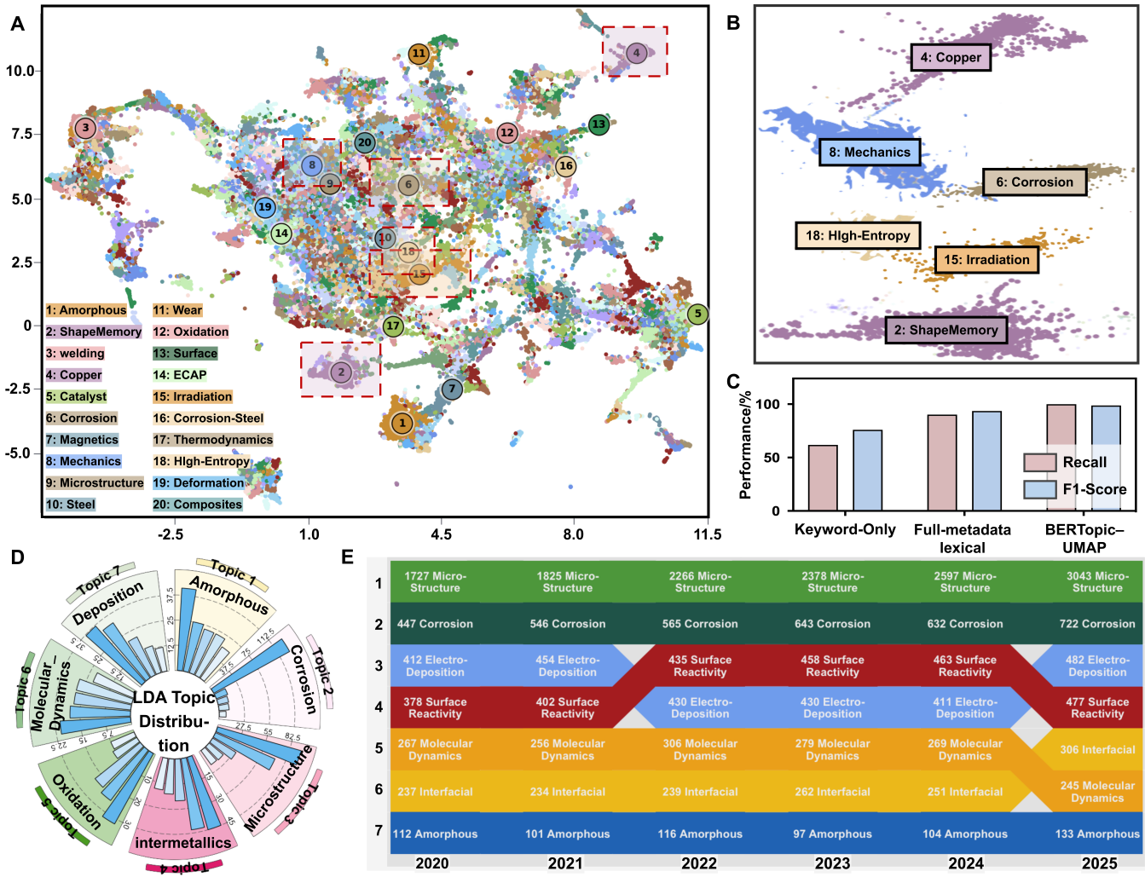
Fig. 2. Corpus–Topic semantic organization of alloy literature using BERTopic-UMAP and LDA. (A) UMAP visualization of the corpus-level alloy semantic space constructed from 122,982 publications, where each point represents a publication and colors indicate BERTopic-derived semantic clusters. (B) Enlarged view of representative corpus-level semantic regions, highlighting the distribution of copper-related studies across multiple domains. (C) Ground-truth comparison of recall and F1-score for keyword-only retrieval, full-metadata lexical retrieval, and BERTopic–UMAP semantic filtering on the 500-publication validation cohort. (D) LDA-based topic distribution, illustrating the hierarchical organization of major research themes and their relative proportions within the corpus. (E) Temporal evolution of topic distributions over 2020–2025, illustrating changes in research focus across major copper-alloy-related themes.
- A core tenet of materials genome engineering is linking processing to micro-structure to properties. However, the machine learning feature set described in Supplementary Table 2 raises concerns: The current features include composition​ (Ni, Si, Cr content, Ni/Si ratio) and processing​ (solution temperature/time, aging parameters, cold rolling reduction), but explicit microstructural features (e.g., dislocation density, precipitate size/distribution, grain size, texture) are absent. This is a significant gap: the experimental results show electrical conductivity prediction errors up to 13.37%, which the authors attribute to microstructure-sensitive electron scattering. Without microstructural descriptors, the models cannot capture the mechanistic link between processing and property variation. The multi-modal extraction pipeline already processes TEM/EBSD images—please leverage this to add quantitative microstructural features to the dataset. At minimum, include: (1) Average precipitate size (already measured for the optimized alloy in Fig. 9i—extend this to all TEM-containing records); (2) Dislocation density estimates from TEM images; (3) Grain size from EBSD/OM images. Even if image extraction is limited to a subset of records, adding these features will align the framework with materials genome principles and improve model interpretability. Clarify in the revised manuscript whether microstructural data from images/tables were considered as model inputs, and if not, why.

Response:
We sincerely thank the reviewer for this important suggestion. We fully agree that quantitative microstructural descriptors, including precipitate size, dislocation density, grain size, and texture, are essential for establishing complete processing–structure–property relationships. We have therefore clarified the role of the image-processing pathway in the Corpus–Topic–Document framework and the reason why literature-derived micro-structural information was not directly incorporated as the universal machine-learning feature set in the present study.
The image-processing pathway was designed to preserve and organize graphical evidence during document-level CPSP reconstruction. Microstructural figures, including TEM, SEM, EBSD, and OM images, are retrieved together with their figure captions, panel identifiers, sample conditions, processing histories, and associated textual descriptions. Importantly, the structural information conveyed by a scientific figure is rarely determined from the image alone. Authors generally interpret the same visual features through the accompanying Results and Discussion, for example by describing precipitates as “fine and uniformly distributed,” identifying dislocation networks, attributing contrast to a specific phase, or associating grain refinement with a particular processing step. The graphical evidence and its corresponding textual interpretation must therefore be considered jointly to preserve the original metallurgical context. However, these author-reported structural descriptions are difficult to convert into consistent numerical features across a large literature corpus. First, structural information contains both qualitative and quantitative descriptions. Expressions such as “dense dislocation networks,” “coarse precipitates,” “homogeneous dispersion,” or “significant grain refine-ment” depend partly on the authors’ interpretation and do not correspond to universally defined numerical scales. Even apparently quantitative descriptors are not always directly comparable. For example, precipitate size may refer to diameter, radius, length, equivalent-circle diameter, or a fitted distribution mean, whereas grain size may be reported using line-intercept, equivalent-diameter, or area-weighted methods. Different authors may therefore describe or quantify similar structures using different criteria.
Second, numerical measurements derived from literature images are strongly affected by image-specific acquisition and sampling conditions. TEM, SEM, EBSD, and OM figures differ in magnification, scale-bar length, spatial resolution, contrast, field of view, sample orientation, specimen thickness, and image-processing procedures. A precipitate size or dislocation-density estimate obtained from one selected micrograph is statistically valid only for the specific field of view and sampling strategy used in that publication. Without access to the original image series, raw EBSD maps, multiple representative fields, or complete measurement protocols, it is difficult to determine whether the published figure is statistically representative of the entire sample. Consequently, directly re-measuring a single published panel may generate an apparently precise value that is not necessarily comparable with values reported in other studies.
Third, the availability of quantitative structural information is highly uneven. Only a subset of publications provides images with sufficiently clear scale bars, resolution, phase identification, and sample correspondence for reliable measurement. Many figures are compressed, cropped, annotated, or presented as multi-panel composites, while some structural observations are reported only qualitatively in captions or discussions. Requiring image-derived precipitate size, dislocation density, and grain size as universal ML inputs would therefore exclude a substantial proportion of otherwise complete composition–processing–property records and sharply reduce the effective dataset size. Alternatively, extensive imputation would introduce additional assumptions and potentially obscure the physical meaning of these descriptors.
For these reasons, the current graphical pipeline does not treat every published micrograph as an independent source of universally standardized numerical features. Instead, the extracted images are linked with their captions and associated textual descriptions to support three functions: (i) preserving structural information within the CPSP data chain, (ii) verifying whether text-derived structural statements are supported by the corresponding graphical evidence, and (iii) maintaining traceability between composition, processing condition, microstructural interpretation, and measured performance. Thus, image information is currently used to improve the completeness and reliability of CPSP reconstruction rather than being directly forced into the ML feature matrix. In other words, the graphical pathway contributes primarily to cross-modal evidence validation and knowledge completeness, whereas the downstream ML feature set prioritizes cross-record comparability, coverage, and numerical consistency. This distinction is necessary because image-level structural evidence may be valid and valuable within an individual publication but may not yet constitute a sufficiently standardized descriptor across thousands of heterogeneous studies.
Nevertheless,we agree with the reviewer that quantitative image-derived descriptors represent an important future extension. A reliable structure-aware model would require a dedicated normalization framework incorporating image-quality screening, scale calibration, segmentation uncertainty, unified definitions of precipitate and grain metrics, multiple-field sampling, and confidence estimates. Future work will therefore focus on constructing curated structural subsets in which precipitate size distributions, grain-size statistics, dislocation-density estimates, and texture descriptors can be extracted under consistent criteria and subsequently integrated with composition and processing variables. The revised manuscript now explicitly states this methodological boundary and clarifies that the present image-processing pathway supports CPSP reconstruction and evidence verification, rather than claiming universal quantitative microstructure metrology from heterogeneous published figures.

Revised Introduction:
However, extensive CPSP knowledge embedded in the copper-alloy literature is rarely available in unified, structured, and machine-readable forms [9]. Instead, it is dispersed across textual descriptions, experimental tables, and graphical resources. Key information concerning alloy composition, heat treatment, deformation, microstructural evolution, strengthening mechanisms, and mechanical properties is often distributed among experimental procedures, Results and Discussion sections, figure captions, and mechanism analyses,where it is expressed using non-standardized and context-dependent terminology. Variations in table layouts, hierarchical headers, and annotation styles further hinder cross-publication data alignment and reconstruction [10]. Graphical resources, including microstructural images, diffraction patterns, and performance curves, provide essential evidence of phase transformation, structural evolution, and property responses. Nevertheless, the metallurgical meaning of a microstructural image cannot usually be inferred from visual appearance alone; phase identity, precipitate morphology, defect structures, and processing-induced microstructural changes are commonly established through the authors’ interpretations in the figure captions and accompanying discussion. Reliable structural-knowledge reconstruction therefore requires the joint association of graphical evidence, textual interpretation, sample conditions, and experimental context. This fragmented, heterogeneous, and cross-modal distribution of CPSP knowledge makes its systematic organization, semantic alignment, and effective utilization a major challenge for copper-alloy informatics and intelligent materials design [11–12]. (Clarify that microstructural knowledge requires joint interpretation of images and text.)

Revised Results 1:
- 3 Document-level: Fine-grained multi-modal CPSP reconstruction
The CPSP image structuring pipeline further extends the framework to literature figure extraction and categorization. Figure links, captions, and associated metadata are first extracted from XML/HTML articles, followed by automated image downloading and multi-panel figure separation. Subsequently, vision-language models are employed to classify different categories of scientific figures, including microstructural images (e.g., SEM, TEM, EBSD, and OM), diffraction patterns, schematic mechanism diagrams, statistical plots, and quantitative performance curves. Different categories of graphical information are then processed according to their information characteristics. Statistical plots and performance curves containing explicit axes and scales are further digitized into structured “x/y-axis–attribute–value” records, enabling direct reconstruction of numerical condition–value pairs. In contrast, microstructural images are linked with their corresponding figure captions, processing conditions, sample identifiers, and associated textual descriptions to reconstruct structural evidence within the CPSP data chain, rather than being directly converted into standardized numerical features. This is because the metallurgical significance of microstructural images, such as phase identification, precipitate morphology, grain refinement, and defect structures, generally depends on the authors’ interpretation in the accompanying text rather than on image appearance alone. Moreover, although some publications report quantitative descriptors such as precipitate size or grain size, these measurements are often obtained using different imaging and statistical protocols, making them difficult to standardize across a large literature corpus. Therefore, the current graphical pipeline preserves image-derived structural information as traceable CPSP knowledge and cross-modal evidence instead of directly incorporating it into the downstream ML feature matrix. Finally, structured text-, table-, and figure-level outputs are integrated into a unified copper-alloy repository through schema harmonization and shared identifiers, including publication DOI, alloy system, sample ID, composition, processing route, processing conditions, structure, properties, and strengthening mechanisms. This repository-level integration enables traceable CPSP reconstruction while preserving the complete experimental context for downstream data-driven modeling, mechanistic interpretation, and future structure-aware materials infor-matics. (Clarify roles of mictural-image evidence reconstruction within the graph-ical pipeline)

Revised Results 2:

3.5.1 Data-Driven Feature Engineering and Alloy Multi-objective Prediction
To evaluate the applicability of the reconstructed CPSP resources for data-driven copper alloy design, 3,358 CPSP records were selected from 9,284 ML-ready data chains by retaining samples with comparable thermo-mechanical processing histories following the route of “Solution → Quenching → Deformation → Aging → Secondary TMP → Secondary Aging” across representative Cu–Ni–Si- and Cu–Cr-based alloy systems. Based on these data, multi-objective machine-learning (ML)models were developed for hardness, electrical conductivity and Q3-Euclidean prediction, while the CPSP-oriented feature engineering workflow was employed to identify key descriptors governing composition–processing–structure–performance relationships. To ensure cross-record consistency and sufficient data coverage, only descriptors that were consistently defined and broadly available across the reconstructed CPSP records were included as ML inputs. Although structural information extracted from text, tables, and microstructural figures was preserved within the CPSP repository for mechanistic interpretation and cross-modal validation, image-derived microstructural descriptors were not used as universal numerical features because of their heterogeneous reporting and limited availability across the literature. (Answer why microstructural data from images were noy considered as model inputs) The dataset was randomly divided into training and testing subsets using an 8:2 ratio, with the testing set reserved for independent evaluation. Within the feature engineering stage, a three-step CPSP-oriented feature screening strategy consisting of correlation filtering, permutation-importance refinement, and combina-tional optimization was employed to identify key factors governing multi-objective properties in these copper alloy systems [4,40].
Revised Discussions:
Despite these advances, several limitations remain. First, the current framework should be interpreted within the scope of repository-level integration. Textual, tabular, and figure-derived information are primarily linked through shared metadata, such as DOI, alloy system, composition, processing route, and performance descriptors, rather than through fully automated entity-level alignment. Consequently, the reconstructed CPSP chains represent coordinated organization of heterogeneous knowledge sources rather than complete cross-modal semantic fusion. A further limitation concerns the incorporation of literature-derived microstructural information into downstream ML models. Although the present framework reconstructs structural evidence by linking microstructural images with their captions and associated textual descriptions, these image-derived observations are not yet sufficiently standardized to serve as universal numerical descriptors across the literature. Their interpretation depends on author-specific analyses, while quantitative measurements are often obtained using different imaging conditions, sampling strategies, and statistical definitions. Consequently, the current framework uses graphical information primarily to preserve structural knowledge, support cross-modal validation, and maintain CPSP traceability rather than as direct ML inputs. Future work will focus on standardized quantitative image analysis and descriptor normalization to establish structure-aware CPSP prediction models. (Explain the methodological gap between CPSP imaging reconstruction technique and standard-ized quantitative microstructure feature generation)

- The distinction between BERTopic (corpus-level semantic filtering) and LDA (topic-level organization) is well explained, but the rationale for using 7 LDA topics needs justification beyond coherence scores. Do these 7 topics align with established subfields in copper alloy research (e.g., precipitation strengthening, corrosion, additive manufacturing)? A brief discussion would strengthen the interpretability of the topic model.

Response:
We sincerely thank the reviewer for this insightful comment. We agree that the selection of the optimal number of LDA topics should not rely solely on a statistical metric, and that the resulting topic organization should also be scientifically interpretable. Following this suggestion, we carefully revisited the corresponding sections in both the main manuscript and the Supplementary Materials. The revised manuscript now further explains the rationale for selecting seven topics, clarifies their correspondence with established research directions in copper alloy science, and expands the discussion on the role of topic-level organization within the proposed CTD framework.
In the present study, the topic coherence score was used only as the initial quantita-tive criterion to identify an appropriate topic number. The final 7-topic-based LDA was determined by jointly considering statistical coherence together with the semantic separability and scientific interpretability of the reconstructed topics. A smaller number of topics tended to merge conceptually different research directions into overly broad themes, whereas increasing the number of topics resulted in semantically overlapping and fragmented topics without providing additional meaningful knowledge organization. The revised Results (Section 3.2) now explicitly clarifies this selection strategy, while the corresponding topic coherence analysis is retained in the Results section as the quantitative basis for model selection.
To further improve the interpretability of topic model, we expanded the discussion of the reconstructed thematic modules. Rather than representing purely statistical clusters, the seven topics correspond well to the major research directions of copper alloy, including precipitation strengthening, thermo-mechanical processing, corrosion behavior, electrical conductivity, microstructural evolution, mechanical properties, and alloy design. These interpretations are consistently supported by the representative keywords, associated publications, and topic evolution presented in Fig. 3, demonstrating that the topic organization reflects the scientific structure of copper alloy research rather than simply maximizing a statistical evaluation metric. To make this correspondence more explicit, we have further summarized the metallurgical interpretation of each topic in the revised manuscript and Supplementary Materials. More importantly, we further clarified the significance of the topic-level organization within the CTD framework. The objective of LDA is not merely to partition the literature into several semantic clusters, but to establish an interpretable knowledge-organization layer between corpus-level semantic filtering and document-level CPSP reconstruction. By organizing semantically related publications into coherent research themes, the CTD framework transforms a large and heterogeneous literature corpus into structured knowledge modules that facilitate subsequent CPSP reconstruction, knowledge exploration, and task-oriented dataset generation. Therefore, 7-topic organization is meaningful not only because it provides an appropriate statistical partition of the literature corpus, but also because it establishes the semantic bridge connecting large-scale literature mining with downstream CPSP reconstruction and data-driven alloy informatics. Accordingly, the revised manuscript now demonstrates that the selection of 7 LDA topics is supported by both statistical evidence and metallurgical interpretation, and that the resulting topic organization enhances the scientific interpretability of the CTD framework rather than serving only as a conventional topic-modeling result.
Revised Results :
3.2. Corpus–Topic Semantic Organization: From Literature Filtering to Knowledge Structuring
As shown in Fig. 3A, the coherence score reaches its maximum when the topic number is seven, indicating that seven topics provide the most semantically consistent representation of the filtered copper-alloy corpus. Nevertheless, topic coherence was used only as the initial statistical criterion for model selection. The final seven-topic organization was further supported by the semantic separability and metallurgical interpretability of the reconstructed topics, avoiding both excessive topic merging and unnecessary semantic fragmentation. (Explain the rationale for using 7 LDA topics) Based on this optimized topic configuration, the topic distribution in Fig. 2C shows a structured yet non-uniform pattern, where dominant themes such as structure–property relationships, corrosion, deposition, interfacial reactions, and amorphous/alloy systems occupy the center of the knowledge landscape. This is consistent with the topic weight distribution in Fig. 3B, which shows uneven contributions, with several dominant topics accompanied by smaller but scientifically meaningful topics, forming a clear long-tail structure.
Table 1. LDA topic probability distribution of the copper alloy literature corpus
Topic | Representative Research Theme | Topic Contents | Probability
Topic 1 | Amorphous alloys and thermal stability | 0.041*"Thermal_stability" + 0.030* "Metallic_glass" + 0.025* "Magnetic_ property" + 0.023* "Crystallization" + 0.023*" Amorphous_ alloy" + 0.022*"Cu" +0.022 *"Bulk_metallic_ glass" + 0.020* "High_ entropy_ alloy" + 0.019* "Glass_forming_ ability" + 0.012* "Plasticity" | 6.67%
Topic 2 | Corrosion behavior and surface protection | 0.074*"Corrosion" + 0.054*"Copper" + 0.026 * "Alloy" + 0.025* "Corrosion_ resistance" + 0.019* "Resistance" + 0.018* "Wear" + 0.016*" Coating" + 0.015* "Behavior" + 0.012*"Copper_alloy" + 0.012* "Steel" | 13.35%
Topic 3 | Microstructure–property relationships and precipitation strengthening | 0.095*"Microstructure" + 0.071* "Mechanical_ properties" + 0.039* "Alloy" + 0.030* "Behavior" + 0.020*"Precipitation" + 0.019*" Strength" + 0.016* "Copper" + 0.015*"Evolution" + 0.013*" Aluminum_ alloy" + 0.012*"Deformation" | 36.61%
Topic 4 | Interfacial reactions and joining technologies | 0.028*"Cu" + 0.026*"Interface" + 0.026* "Intermetallic_compound" + 0.025*"Joint" + 0.022* "Alloy" + 0.021*" Shape_ memory_ alloy" + 0.019* "Solder" + 0.019*"Inter-metallic" + 0.019* "Stainless_steel"+ 0.017* "Interfacial_ reaction" | 10.22%
Topic 5 | Nanostructured functional copper materials | 0.040*"Catalyst" + 0.032*"Nanoparticle" + 0.025* "Oxidation" + 0.019*"Copper" + 0.016* "Electro-catalyst" + 0.015* "Reduction" + 0.012* "Alloy" + 0.012*"Cu" + 0.011* "Performance" + 0.011*" Surface" | 8.9%
Topic 6 | Solidification and computational metallurgy | 0.038*"Alloy" + 0.021*"Solidification" + 0.019* "System" + 0.018* "Diffusion" + 0.017*"Molecular_ dynamics" + 0.017* "Segregation" + 0.015*"Growth" + 0.013* "Simulation" + 0.013*" Cu" + 0.012* "Iron" | 11.11%
Topic 7 | Electro-deposition and thin-film fabrication | 0.039*"Copper" + 0.026*"Alloy" + 0.024* "Electrodeposition" + 0.023*"Cu" + 0.021* "Fabrication" + 0.018*"Film" + 0.016* "Thin_film" + 0.014*"Deposition" + 0.014*" Mechanical_ alloying" | 13.15%
Furthermore, Fig. 2D and Fig. 3D reveal the temporal evolution of research focus and its underlying keyword-level semantic basis. Structure-related studies consistently maintain a high proportion, under-scoring their central role in copper alloy research, while topics such as corrosion, surface reactions, electrodeposition, molecular dynamics, and interfacial phenomena exhibit noticeable temporal variations. This trend is further supported by the keyword distribution in Fig. 3D, where terms such as microstructure, mechanical properties, corrosion, precipitation, and strength define the core semantic regions. Overall, these results suggest that copper alloy research is increasingly organized around coupled structure–property relationships, multi-mechanism strengthen-ing, and multi-scale investigations. The inter-topic similarity heatmap in Fig.3C indicates low-to-moderate correlations, suggesting that the LDA topics are generally distinguish-able while maintaining limited semantic connections. Overall, these results demonstrate that the reconstructed seven-topic organization is not merely a statistically optimal partition of the corpus, but also corresponds to established research directions in copper alloy science. Consequently, the resulting topic structure provides a scientifically interpretable organization of the copper alloy literature.
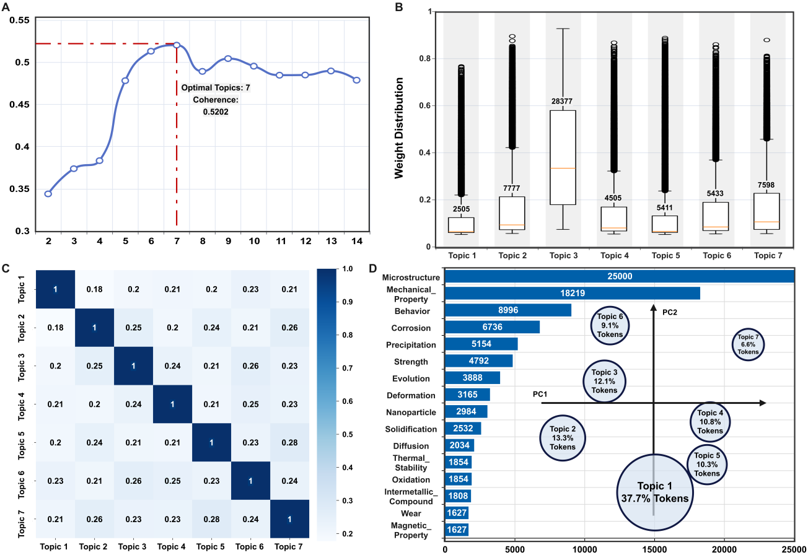
Fig. 3. Topic-level knowledge organization and statistical characteristics of the copper-alloy-relevant literature corpus. (A) Variation of coherence score with the number of topics, indicating an optimal topic number of 7. (B) Topic weight distribution, reflecting the relative contributions of different topics within the corpus. (C) Topic correlation matrix, illustrating the semantic relationships among topics. (D) Keyword frequency distribution and two-dimensional projection of topics in the principal component space, where circle size represents the proportion of each topic in the corpus.

The full distribution of alloy systems in the final CPSP database should be clearly reported. The Q3-Euclidean index is used as a multi-objective metric, but its formula-tion (Eq. 1 in the main text) normalizes hardness and conductivity to their min-max ranges in the virtual screening database. Please clarify whether these min-max values are derived from experimental data or model predictions, as this affects the interpret-ability of the index. The formula for Q3-Euclidean in the supplementary materials is inconsistent with the main text—please correct all typographical error. The TEM characterization of the optimized alloy shows an average precipitate size of ~4.39 nm, but no error bars are provided. Please add standard deviations for precipitate size and other microstructural parameters to quantify measurement uncertainty.

Response:
We sincerely thank the reviewer for these thoughtful and constructive suggestions. We fully agree that the distribution of alloy systems in the reconstructed CPSP database, the normalization and mathematical consistency of the Q3-Euclidean index, and the statistical uncertainty of the TEM-derived microstructural measurements should be more explicitly reported. Following the reviewer’s suggestions, we carefully revisited the corresponding data, calculations, figures, and descriptions in both the main manuscript and the Supplementary Materials and made the following revisions.
First, regarding the distribution of alloy systems in the final CPSP database, we recognized that, although the original manuscript reported the overall scale of the reconstructed CPSP infrastructure (3,245 publications and 9,284 structured CPSP records), the distribution and knowledge coverage of individual copper-alloy systems were not described sufficiently explicitly. Following the reviewer’s suggestion, we have therefore reorganized and expanded the corresponding database characterization in the Supplementary Materials Note S7 and further supplemented with a description of the corresponding figure. Specifically, the revised supplementary materials describe the distribution of major copper-alloy systems and their relationships with alloying-element categories, representative processing routes, and multiscale structural information reconstructed from the literature. This expanded analysis provides a clearer overview of the compositional diversity and CPSP knowledge coverage of the final database, demonstrating that it encompasses a broad range of copper-alloy systems and associated processing–structure information. Accordingly, the corresponding section of the main manuscript has been streamlined, while the detailed database distribution and its analysis are now provided in Supplementary Note S8 and Supplementary Fig. S4.

Revised Supplementary Material :

Supplementary Note S8. Distribution and Knowledge Coverage of the Final CPSP Database

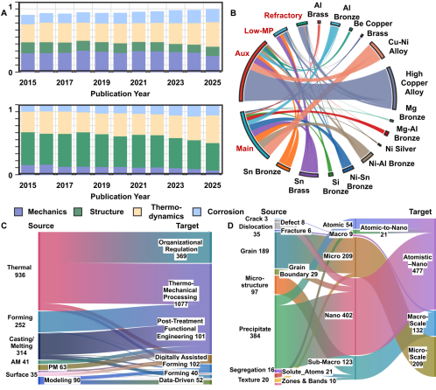
Supplementary Fig. S4. Distribution and knowledge coverage of the final structured CPSP database.(A) Annual normalized distributions of mechanics-, structure-, thermo- dynamics-, and corrosion-related research represented in the database from 2015 to 2025. (B) Relationships between copper-alloy systems and main, auxiliary, low-melting-point, and refractory alloying-element categories. (C) Relationships between source processing descrip- tions and normalized processing-route categories. (D) Relationships between extracted structural descriptors and their atomic-to-macroscopic scale classifications.

The CPSP infrastructure reconstructed in this study comprises 3,245 publications and 9,284 structured CPSP records. Supplementary Fig. S4 further characterizes its knowledge coverage from three complementary dimensions: the distribution and compositional relationships of copper-alloy systems, the coverage of processing routes, and structural information across characteristic length scales. Together, these dimensions describe how composition, processing, and structure are organized within the final CPSP database.
Supplementary Fig. S4A and B show that the reconstructed records span diverse copper-alloy families and research domains rather than a single compositional space. The literature covers mechanics-, structure-, thermodynamics-, and corrosion-related research, while the alloy systems include high-copper alloys, Cu–Ni alloys, brasses, nickel silver, and multiple bronze families, including Al-, Be-, Mg-, Ni–Al-, Ni–Sn-, Si-, and Sn-containing bronzes. Their relationships with main, auxiliary, low-melting-point, and refractory alloying elements further preserve the compositional connections among different alloy families and alloying strategies, demonstrating broad coverage of the Cu-based compositional space.
Supplementary Fig. S4C extends this coverage to processing histories, including thermal processing, forming, casting and melting, additive manufacturing, surface processing, powder metallurgy, and modelling, together with their normalized processing categories. These relationships preserve preparation, deformation, heat-treatment, surface-modification, and post-treatment information, providing the intermediate processing layer required to reconstruct Composition–Processing–Structure–Property/Performance relationships rather than reducing the literature to composition–property pairs.
Supplementary Fig. S4D further organizes structural information across atomic, nanoscale, microscale, sub-macroscale, and macroscale levels. Extracted descriptors include precipitates, grains, microstructure, segregation, texture, dislocations, and cracks, together with more specific features such as solute atoms, zones and bands, grain boundaries, and defect- and fracture-related information. Thus, the reconstructed structure layer preserves information ranging from solute and defect states to nanoscale precipitation, grain-scale microstructures, and larger-scale structural characteristics.
Collectively, these distributions demonstrate that the final database constitutes a structured CPSP knowledge infrastructure rather than a conventional composition–property table. By integrating diverse copper-alloy systems, alloying-element relationships, processing histories, and multiscale structural information, it provides a reusable basis for task-specific dataset generation, CPSP relationship analysis, knowledge-informed feature engineering, machine learning, and subsequent alloy design.
Second, regarding the formulation and interpretability of the Q3-Euclidean index, we agree that the source of the min–max normalization ranges should be explicitly clarified. The minimum and maximum values used in Eq. (1) are not derived from model predictions, but exclusively from the experimentally measured hardness and electrical conductivity values in the curated ML-ready CPSP dataset after data cleaning and preprocessing. The normalization ranges therefore correspond to the experimental property boundaries of the virtual-screening dataset (Hardness: 60–386 HV; Electrical Conductivity: 12–92 %IACS) and remain fixed throughout feature engineering, model training, virtual screening, candidate ranking, and experimental validation. Consequently, all predicted values are normalized against a predefined experimental property space rather than against the prediction distribution of the machine-learning models. The Q3-Euclidean index therefore represents the normalized Euclidean distance between each candidate alloy and experimentally defined ideal strength–conductivity target, providing a physically interpretable metric for evaluating balanced mechanical and electrical performance within a common design space.
We also carefully re-examined the Q3-Euclidean equation in the Supplementary Materials and confirmed that the inconsistency identified by the reviewer resulted from a typographical error rather than from the actual implementation of the calculation. The equation in the Supplementary Materials has now been corrected to be fully consistent with Eq. (1) in the main manuscript. Importantly, all feature engineering, machine-learning training, virtual screening, candidate ranking, and reported Q3-Euclidean values were calculated using the correct equation throughout this study. Therefore, this correction is purely editorial and does not affect any numerical results, figures, discussions, or conclusions presented in the manuscript. To further improve clarity, the main manuscript and supplementary materials has been revised to explicitly state the origin of the normalization ranges.
Revised Supplementary Material :
Note S5: Feature Descriptor System for Machine learning in the rapid alloy design module
Supplementary Table 2. Feature descriptors for synergistic optimization of Cu alloys
Q3-Euclidean | Q3 = Sqrt [((HV-HVmin)/ (HVmax-HVmin)-1)^2 + ((EC- ECmin)/(ECmax-ECmin)-1)^2] | Multi-objective performance metric

Revised Material and Methods:
- Machine-Learning-Guided Alloy Design and Experimental Validation
To validate the practical applicability of the proposed Corpus–Topic–Document framework for alloy discovery, machine-learning-guided design and experimental investigations were conducted on Cu–Ni–Si–Cr alloys targeting synergistic optimization of strength and electrical conductivity. A total of 950,400 composition–processing combinations were virtually screened using the trained machine learning models, rather than experimentally fabricated. These candidate combinations followed the processing route of “Solution → Quenching → Deformation → Aging → Secondary Thermo-Mechanical Processing (TMP) → Secondary Aging”. The composition design space included Ni (4–6 wt%), Si (1–2.5 wt%), Cr (0.1–0.3 wt%), and optional microalloying additions of Al (0.3–0.5 wt%) and Mg (0.01–0.16 wt%). Although Al and Mg were included in the composition design space during virtual screening, machine-learning predictions indicated that the highest-ranked candidates were located within the Cu–Ni–Si–Cr compositional subspace. Therefore, experimental validation was conducted on the top-performing Cu–Ni–Si–Cr candidates. The processing parameter space included solution treatment at 900–1000 °C for 3–7 h and aging treatment at 300–550 °C for 0.5–5 h. The optimal alloy candidates were identified using the normalized comprehensive performance index Q3-Euclidean, defined as:
$Q3−Euclidean=\sqrt{\text{(}\frac{{HV−{HV}_{\text{min}}}^{ }}{{HV}_{\text{max}}−{HV}_{\text{min}}})^{2}+{(\frac{{EC−{EC}_{\text{min}}}^{ }}{{EC}_{\text{max}}−{EC}_{\text{min}}}\text{)}}^{2}}$ $(2.8)$
where HV and EC represent the hardness and electrical conductivity of a candidate alloy, respectively. HVmin, HVmax, ECmin, and ECmax correspond to the minimum and maximum valuesof hardness and electrical conductivity (60–386 HV and 12–92% IACS) were derived exclusively from experimentally measured values in the cleaned ML-ready CPSP dataset, rather than from model predictions.

Finally, regarding the statistical uncertainty of the TEM characterization, we agree that the dispersion of the precipitate-size measurements should be explicitly reported to improve the quantitative reliability of the microstructural analysis. We therefore re-examined the original TEM measurements and supplemented the precipitate-size statistics with the corresponding standard deviation and sample size. Based on measure-ments of 62 precipitates, the average precipitate size was determined to be 4.39 ± 1.25 nm (mean ± standard deviation, n = 62). The standard deviation and number of measured precipitates have now been added to the corresponding discussion and the caption of Fig. 9i. Figure 9i has also been revised to display the precipitate-size distribution together with the mean value, standard deviation, and sample size. Corresponding revisions have been made in the Materials and Methods section, the discussion of Fig. 9, and the caption of Fig. 9i.
Collectively, these revisions provide a more transparent description of the alloy-system coverage of the CPSP database, clarify the experimental basis and mathematical consistency of the Q3-Euclidean index, and improve the statistical rigor of the TEM-based microstructural characterization. We sincerely appreciate the reviewer’s suggestions, which have helped improve the completeness, interpretability, and quantitative reliability of the revised manuscript.

Revised Material and Methods :
- Machine-Learning-Guided Alloy Design and Experimental Validation
For hardness evaluation, Vickers hardness testing was conducted using an HV-1000 tester under a load of 500 g with a dwell time of 15 s. For electrical conductivity measurement, testing were performed at 25 °C using a digital eddy-current conductivity meter, and the reported values represent the average of five measurements. For mechanical property evaluation, tensile testing was conducted using a universal testing machine (AG-250KINS) with three repeated tests for each alloy condition. For microstructural characterization, field-emission transmission electron microscopy (TEM, G20) was used to characterize the microstructure and precipitation behavior of the optimized alloys. Precipitate sizes were measured from representative TEM images (n = 62) and reported as mean ± standard deviation (SD).

Revised Results :
5.2 CPSP-Guided Experimental Validation and Microstructural Mechanism Analysis
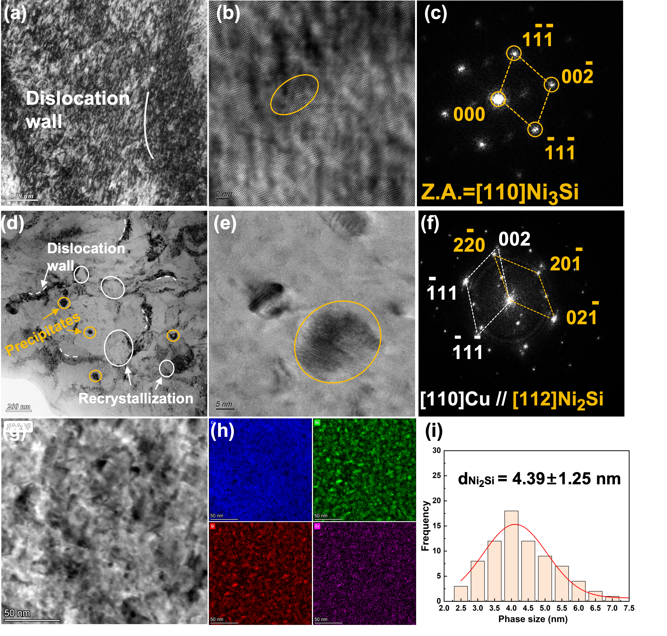
The HAADF-STEM image and STEM-EDS elemental maps in Fig. 9g and h show a relatively uniform distribution of Ni and Si, without obvious coarse segregation or continuous grain-boundary precipitation. This relatively homogeneous precipitation state is beneficial for both mechanical strengthening and electrical transport, as precipitation removes Ni and Si solutes from the Cu matrix and reduces solute-related electron scatter-ing. The precipitate-size distribution in Fig. 9i shows that the Ni2Si precipitates have an average size of 4.39 ± 1.25 nm (mean ± SD, n = 62), with measured sizes ranging from 2.52 to 7.29 nm and most particles concentrated within 3–5 nm. This relatively narrow size distribution indicates limited precipitate coarsening, consistent with the fine and dense precipitation characteristic of the peak-aged state. Therefore, enhanced strength of the alloy originates from combined effects of retained deformation substructures and finely dispersed Ni2Si precipitates, while the improved conductivity is associated with solute depletion from the Cu matrix during precipitation [2-3]. The microstructural evidence in Fig.9 therefore provides mechanistic support for the strength–conductivity synergy achieved through CPSP-guided alloy design.
Fig. 9. TEM/STEM characterization and precipitation analysis of the peak-aged Cu–Ni–Si–Cr alloy after cold deformation. (a) Low-magnification TEM image showing retained high-density dislocation sub-structures and dislocation walls in the deformed Cu matrix. (b) HRTEM image of nanoscale precipitates embedded in the Cu matrix. (c) Corresponding FFT pattern of the precipitate marked in (b), indexed as Ni₃Si viewed along the [110] zone axis.(d) Bright-field TEM image showing the coexistence of dislocation walls, nanoscale precipitates, and locally recrystallized regions. (e) HRTEM image of a representative nanoscale precipitate in the matrix. (f) Corresponding SAED/FFT pattern revealing the crystallographic relationship between the Cu matrix and Ni₂Si precipitate, with [110]Cu//[112]Ni₂Si. (g) HAADF-STEM image of the aged microstructure. (h) STEM-EDS elemental maps of Cu, Ni, Si, and Cr, showing the elemental distribu-tion in the observed region. (i) Statistical analysis of the TEM images yielded an average precipitate size of 4.39 ± 1.25 nm (mean ± SD, n = 62), with sizes ranging from 2.52 to 7.29 nm (Fig. 9i).

Recommendations for Revision. Quantify semantic filtering advantages: Add a comparative analysis of keyword-based vs. BERTopic-based retrieval, including precision/recall metrics on a manually labeled test set, and discuss the trade-offs of semantic filtering for materials literature mining. Expand feature set: Integrate quantitative microstructural descriptors (precipitate size, dislocation density, grain size) extracted from images/tables into the machine learning feature space. Even a pilot implementation for a subset of records will significantly enhance the work’s alignment with materials genome principles. Address data heterogeneity: Develop and document a standardized processing schema and data reconciliation protocol to handle inconsistencies across literature sources. Report the impact of heterogeneity on model performance and discuss limitations. Correct errors and clarify terminology; Fix all data errors in supplementary tables, unify terminology, and proofread all equations, figures, and references. Strengthen discussion: Explicitly link the CTD framework to materials genome engineering goals (e.g., FAIR data principles, accelerated discovery pipelines) and discuss its transferability to other alloy system

